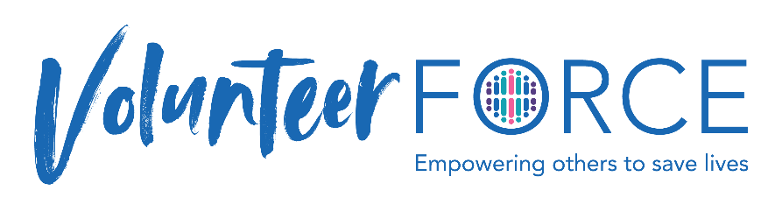
Unable to Connect Email – Send if no response from match.
Volunteer Instructions
Step 1: Copy and paste the words below into an email. Be sure to paste with the option to Keep Text Only.
Step 2: Copy and paste the “FORCE Peer Navigation Follow-up” into the actual subject line of your email. Step
3: Personalize the email by replacing the red wording with appropriate names.
Step 4: Change the red wording color to black so it doesn’t look like a form letter.

Subject Line: FORCE Peer Navigation Follow-up
Dear xxx,
I’ve been trying to reach you. I’m sorry that we were not able to connect. I hope you found the resource guide helpful to make informed decisions with your health care providers. Please save your guide, which automatically updates when new information becomes available, to review at any time during your journey.
Your guide: https://facingourrisk.org/pnp/constituents/v06v2zirpp
If you have questions or need support after reviewing the material, please feel free to email me. You are not alone.
We would really appreciate it if you would provide feedback about the Peer Navigation Program by completing this survey. It is extremely helpful to us, as we strive to provide the best support possible.
https://www.surveymonkey.com/r/WR5L857
Live life empowered!
xxx
FORCE Peer Navigator

