HEALTH INSURER
123 Insurance Way
Anywhere, IL 012345
DATE
RE: Claim # XXXXXXXXXXX
Claimant: NAME (ID# and DOB: Mo-Day-Year)
To Whom It May Concern:
I am writing to appeal to [Health Plan Name]’s decision to deny coverage of treatment of my metastatic breast cancer with Olaparib which took place on [date] at [facility]. It is my understanding that [Health Plan Name] covers medically necessary services that are not expressly excluded. [Attach or reference relevant section(s) from health insurer’s Policy or Evidence of Coverage, if possible.]
In Augusts of 2021, the American College of Medical Genetics and Genomics published Management of individuals with germline variants in PALB2: a clinical practice resource of the American College of Medical Genetics and Genomics (ACMG)¹ and Exhibit A.
Inherited mutations in PALB2 are associated with increased breast cancer risk and smaller increased risk of pancreatic and likely ovarian cancer. The ACMG recognized it was necessary to publish these clinical practice guidelines for management of people with inherited mutations in PALB2 because resources for healthcare providers on managing people with PALB2 mutations were and remain limited.
- ACMG recommends PALB2 heterozygotes should be considered for the same therapeutic regimens and trials as those for BRCA1/2.
In addition to the ACMG recommendation, the National Comprehensive Cancer Network (NCCN)’s Breast Cancer Treatment Guidelines 4.2025 states the preferred treatment for BRCA1 and BRCA2 metastatic cancer are the PARP inhibitors Olaparib and Talazoparib while the treatment for PALB2 metastic breast cancer, Olaparib is the recommended regimen (Exhibit B).
Thank you for your consideration. Your prompt attention to this matter is greatly appreciated.
Sincerely,
[Signature]

___________________________________________________________________________________________________________________________
¹Tischkowitz M, Balmaña J, Foulkes WD, et al. Management of individuals with germline variants in PALB2: a clinical practice resource of the American College of Medical Genetics and Genomics (ACMG). Genetics in Medicine: Volume 23, Issue 8, 2021, Pages 1416-1423, https://doi.org/10.1038/s41436-021-01151-8.
Exhibit A

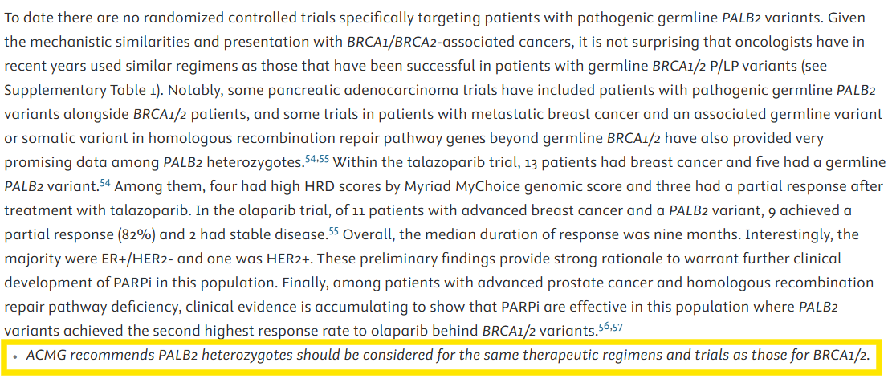

Exhibit B
