HEALTH INSURER
123 Insurance Way
Anywhere, IL 012345

DATE

RE: Claim # XXXXXXXXXXX
Insured: NAME (ID# XXXXXXXXXXX)
Claimant: NAME (DOB Mo-Day-Year)

To Whom It May Concern:
I am writing to appeal [Health Plan Name]’s decision to deny coverage of my Prostate-Specific Antigen (PSA) screening test. Genetic testing confirmed that I carry an inherited BRCA genetic mutation which puts me at increased risk of prostate cancer. Men with BRCA mutations have up to a 40% lifetime risk for prostate cancer, which is much higher than average-risk men.
The most recent U.S. Preventive Services Task Force (USPSTF) Prostate Cancer: Screening guidelines indicate that prostate cancer screening for men ages 55-69 should be an individual decision between a patient and his doctor. These recommendations, however, are for “average risk” men. In regard to high-risk men and those with a family history of prostate cancer, the Task Force notes that “screening may offer additional potential benefits for these men compared with the general population.” In fact, the 2012 USPSTF Prostate Cancer: Screening guidelines recommended against PSA-based screening for prostate cancer in average risk men. Yet, under the Clinical Considerations section of its Final Recommendation Statement, the USPSTF clarified that these guidelines do not apply to men with BRCA mutations:
"This recommendation...does not consider PSA-based testing in men with known BRCA gene mutations who may be at increased risk for prostate cancer." [Exhibit B]
The clinical value of identifying people with a BRCA mutation lies in an individual’s ability to access screening and preventive services that lower the risk of cancer or diagnose the disease at an earlier stage when it is more easily treated. BRCA mutation status is a recognized independent prognostic prostate cancer risk factor and marker of a more aggressive tumor and a worse overall survival.
In 2019, an international panel of experts developed a multidisciplinary, consensus-driven, prostate cancer genetic implementation framework that indicates, “Screening should begin at age 40 or 10 years prior to the age of the youngest prostate cancer diagnosis in the family” among BRCA mutation carriers.
NCCN Guidelines note that men with BRCA mutations should start prostate cancer screening at age 40 due to the increased risk of aggressive, early onset disease with significantly reduced survival rates. [Exhibits C and D] The American Cancer Society recommends prostate cancer screening starting at age 40 for men in the highest risk category, such as myself [Exhibit E].
Recent research supports increased screening and use of PSA tests in men with BRCA mutations. Preliminary results from the IMPACT study “support the use of targeted prostate-specific antigen screening based on BRCA genotype and show that this yields a high proportion of aggressive disease.”,
The American Cancer Society notes that many states have laws requiring private health insurers to cover tests to detect prostate cancer, including the PSA test and digital rectal exam (DRE) and, “Most state laws assure annual coverage for…high-risk men, ages 40 and over.” In states where it is not mandated, many health insurers, including Blue Cross Blue Shield, consider PSA screening starting at age 40 a medically necessary preventive service, especially for high-risk men like myself [Exhibit F].
Prostate cancer screening mechanisms such PSA tests and digital rectal exams are the most effective options for men at increased risk of cancer. Given my BRCA mutation, and the likelihood of aggressive disease, my medical team and I respectfully request that you cover this important screening.
Thank you for your consideration. Your prompt attention to this appeal is greatly appreciated.
Sincerely,
[Signature]

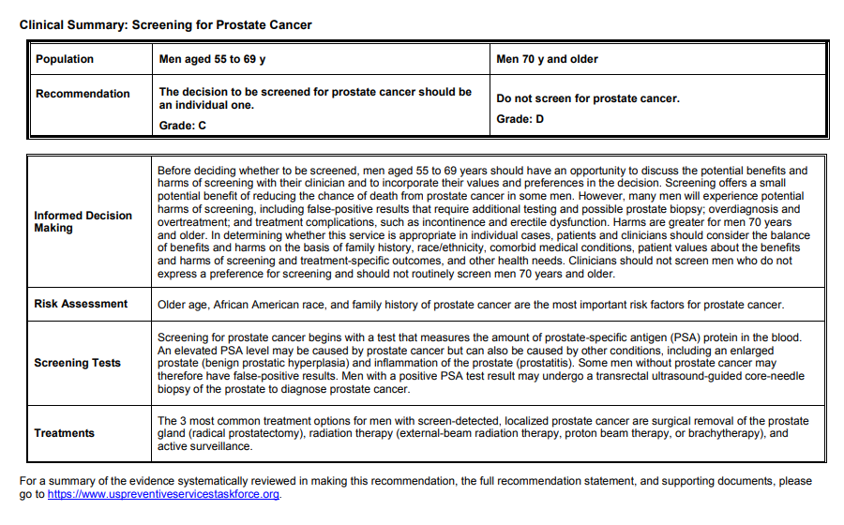Exhibit A
Source: www.uspreventiveservicestaskforce.org/uspstf/recommendation/prostate-cancer-screening
Exhibit B
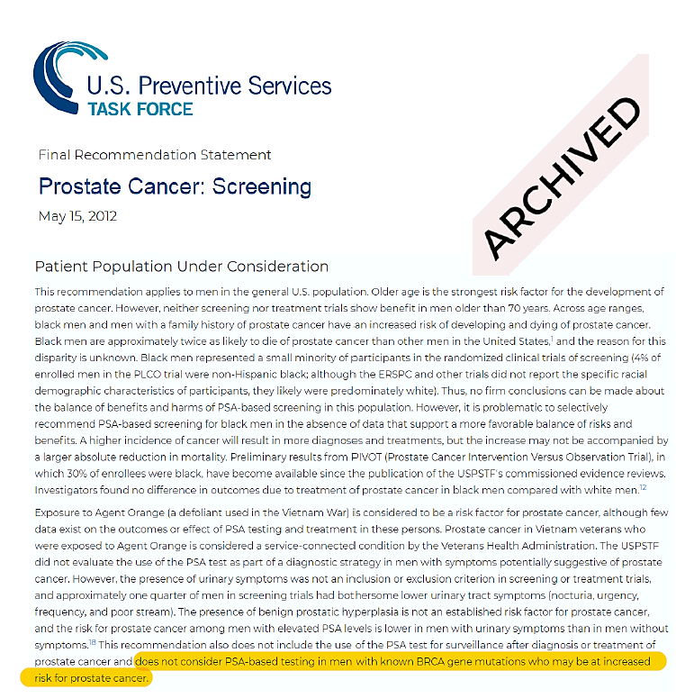

Source:
www.uspreventiveservicestaskforce.org/uspstf/recommendation/prostate-cancer-screening-2012#fullrecommendationstart
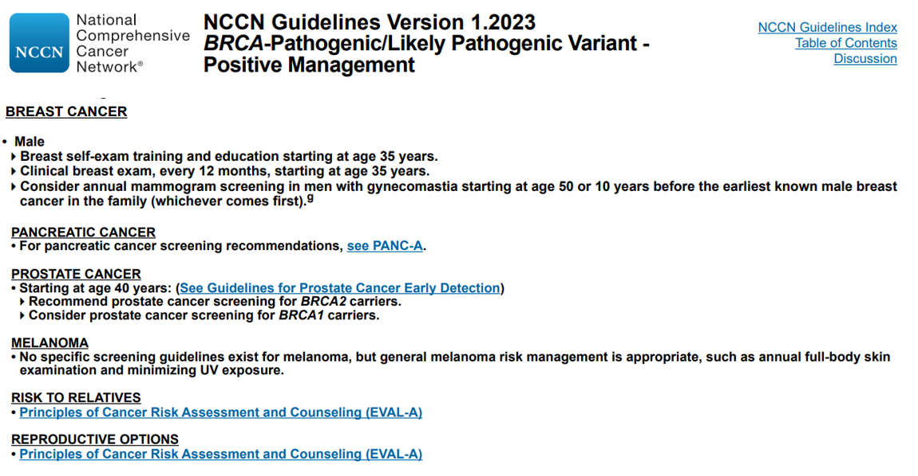
Exhibit C

Exhibit D
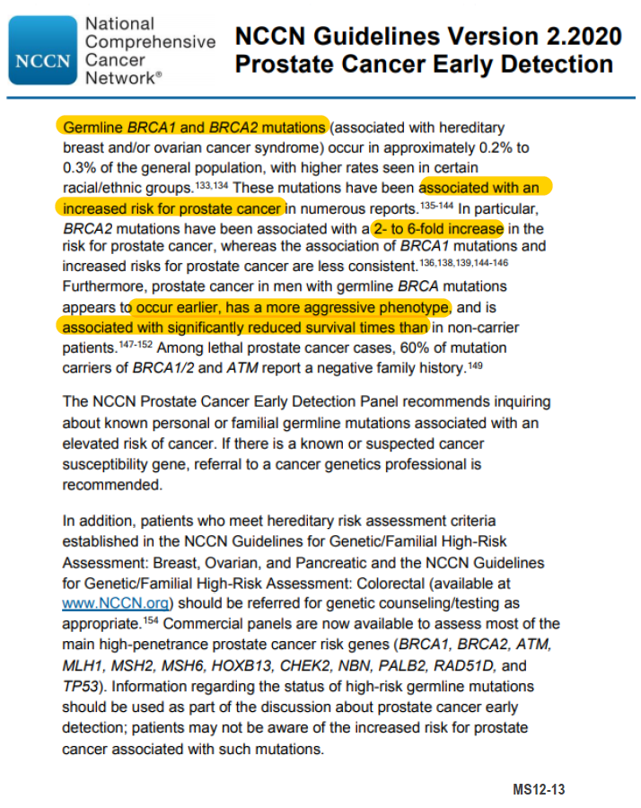

Exhibit E
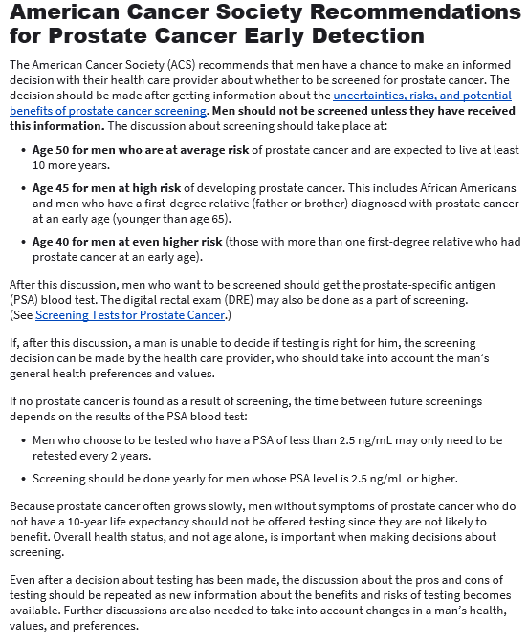
Last Revised: April 23, 2022
Source:
www.cancer.org/cancer/prostate-cancer/detection-diagnosis-staging/acs-recommendations.html

Exhibit F
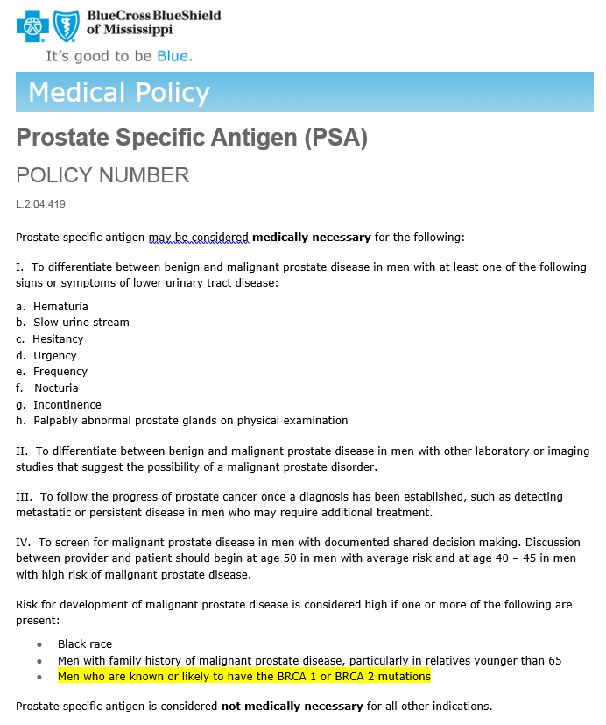
Source:
www.bcbsms.com/medical-policy-search#/policy-detail?id=b611eb92-72f2-4112-a678-6a480d8098d3

JCO, Prediction of Breast and Prostate Cancer Risks in Male BRCA1 and BRCA2 Mutation Carriers Using Polygenic Risk Scores, http://ascopubs.org/doi/full/10.1200/JCO.2016.69.4935
U.S. Preventive Services Task Force Final Recommendation Statement – Prostate Cancer: Screening, www.uspreventiveservicestaskforce.org/uspstf/recommendation/prostate-cancer-screening
Archived U.S. Preventive Services Task Force Final Recommendation Statement – Prostate Cancer: Screening, www.uspreventiveservicestaskforce.org/uspstf/recommendation/prostate-cancer-screening-2012#fullrecommendationstart
Implementation of Germline Testing for Prostate Cancer: Philadelphia Prostate Cancer Consensus Conference 2019. Journal of Clinical Oncology 2020 38:24, 2798-2811, https://ascopubs.org/doi/full/10.1200/JCO.20.00046
American Cancer Society, Insurance Coverage for Prostate Cancer Screening, www.cancer.org/cancer/prostate-cancer/detection-diagnosis-staging/insurance-coverage.html
Targeted prostate cancer screening in BRCA1 and BRCA2 mutation carriers to detect clinically significant disease: Results from the initial screening round of the IMPACT study, https://meetinglibrary.asco.org/record/90940/abstract

