HEALTH INSURER
123 Insurance Way
Anywhere, IL 012345
DATE
RE: Claim # XXXXXXXXXXX
Insured: NAME (ID# XXXXXXXXXXX)
Claimant: NAME (DOB Mo-Day-Year)

To Whom It May Concern:
I am writing to appeal the decision to deny coverage of my pancreatic cancer screening by [Health Plan Name]. Genetic testing confirmed that I carry a [ATM, BRCA1, BRCA2, CDKN2A, STK11, MLH1, MSH2, MSH6, EPCAM, PALB2, or TP53] genetic mutation which puts me at increased risk of pancreatic cancer. The risk of pancreatic cancer is 1.5% in the general population. Mutation carriers like myself face up to a 36% lifetime risk.
The clinical value of identifying people with an inherited genetic mutation associated with increased risk of cancer lies in an individual’s ability to access screening and preventive services that lower that risk by preventing cancer or catching it earlier, when is easier to treat. If pancreatic cancer is diagnosed early, patients may be eligible for surgery, which offers the best chance for cure or long-term control of the disease. Without screening, the cancer is often found too late when surgery is no longer an option. Early detection in individuals with an inherited mutation also may have therapeutic benefit, as tumors containing some mutations can be targeted with new drugs such as PARP or checkpoint inhibitors.

The National Comprehensive Cancer Network (NCCN) recommends “annual contrast-enhanced MRI/MRCP and or EUS, with consideration of shorter screening intervals for individuals found to have worrisome abnormalities on screening.” [Exhibit A] In 2018, the International Cancer of the Pancreas Screening (CAPS) Consortium updated its guidelines, indicating that “pancreatic surveillance is recommended for selected high-risk individuals to detect early pancreatic cancer and its high-grade precursors…” [Exhibit B]
While the U.S. Preventive Services Task Force does not recommend pancreatic cancer screening for the average-risk population, it notes that the recommendation does not apply to high-risk populations
(i.e., “Persons with certain inherited genetic syndromes or a history of familial pancreatic cancer”). [Exhibit C] Many health insurers consider pancreatic cancer screening medically necessary for individuals at increased risk of this deadly disease. Given my significantly increased risk for pancreatic cancer, and the poor prognosis if the disease is not diagnosed at an early stage, my medical team and I respectfully request that you cover this crucial screening.

Thank you for your consideration. Your prompt attention to this appeal is greatly appreciated.
Sincerely,
[Signature]

Exhibit A
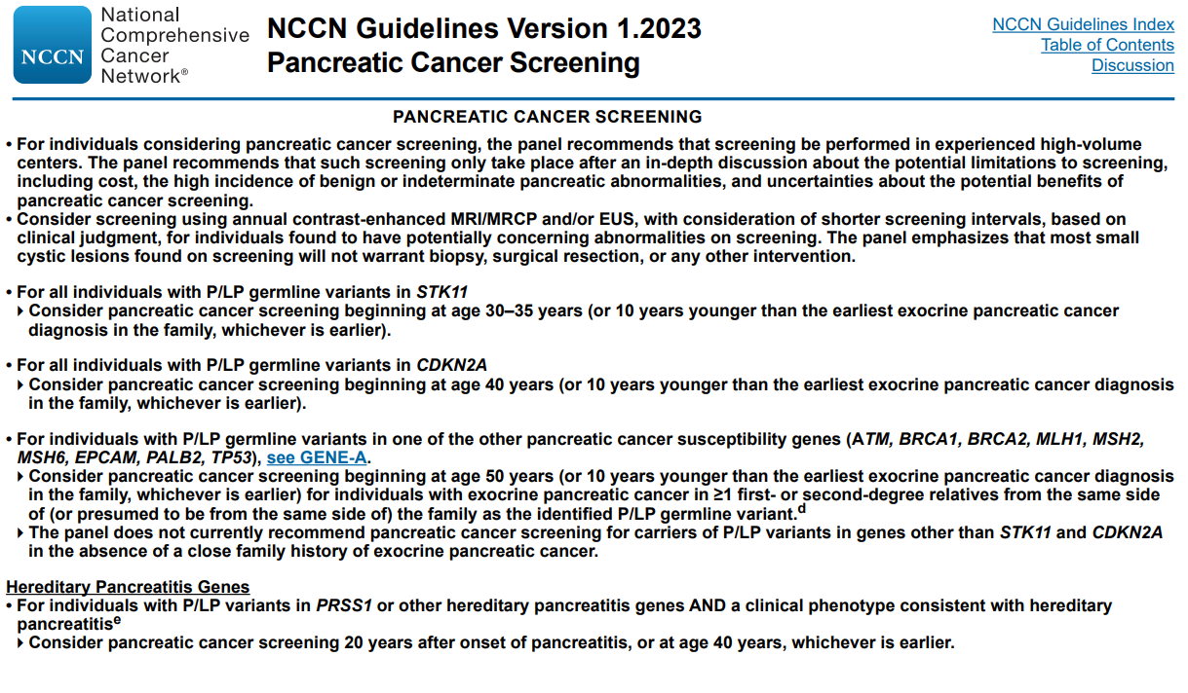

Exhibit B
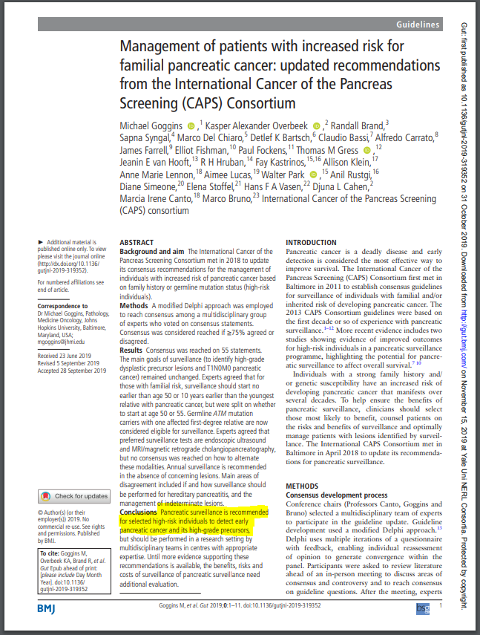

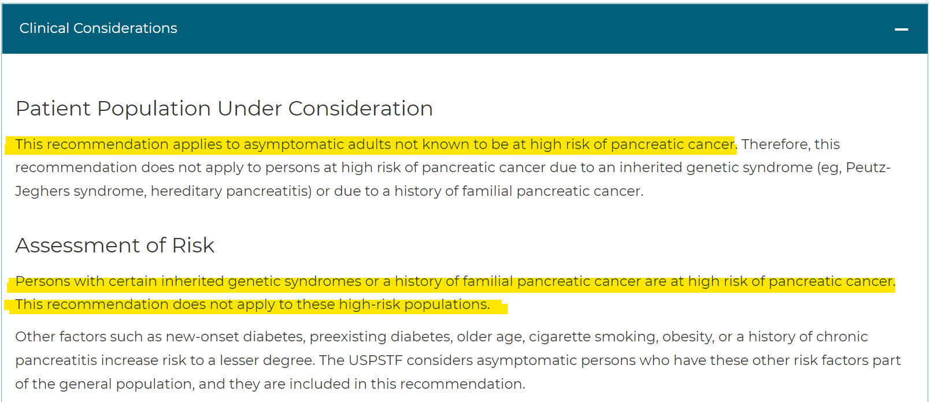
Exhibit C

Source:
www.uspreventiveservicestaskforce.org/uspstf/recommendation/pancreatic-cancer-screening#bootstrap-panel--6

Gut. 2020 Jan;69(1):7-17. doi: 10.1136/gutjnl-2019-319352. Epub 2019 Oct 31. (https://gut.bmj.com/content/69/1/7.long)
U.S. Preventive Services Task FORCE Final Recommendation Statement, Pancreatic Cancer: Screening (www.uspreventiveservicestaskforce.org/Page/Document/RecommendationStatementFinal/pancreatic-cancer-screening1)

