Health Insurer
123 Insurance Way
Anywhere, IL 012345
DATE
RE: Claim # XXXXXXXXXXX
Insured: NAME (ID# XXXXXXXXXXX)
Claimant: NAME (DOB Mo-Day-Year)
To Whom It May Concern:
I am writing to appeal the decision to deny coverage of my prophylactic bilateral mastectomy by [Health Plan Name]. I have a significant family history of early onset, aggressive breast and other cancers. Accordingly, I have been advised to undergo increased screening for breast cancer. In my most recent breast MRI, a suspicious mass was discovered. A biopsy revealed that I have atypical ductal hyperplasia (ADH) and lobular carcinoma in situ (LCIS). ADH is an abnormal pattern of cell growth which has characteristics similar to ductal carcinoma in-situ (DCIS), when the cells that line the milk ducts of the breast have become cancerous. LCIS indicates areas of abnormal cell growth that increase one’s risk of developing invasive breast cancer. As such, ADH and LCIS are precursors to breast cancer.
Due to my LCIS and ADH diagnoses, and strong family history of cancer, I recently had genetic testing to determine if I carry an inherited genetic mutation associated with increased risk of cancer. I would like to note that Medical Mutual paid for this testing. While no known mutation was found, [Risk Assessment Tool] indicates that my risk of breast cancer is XX%. To put this in perspective, the average woman has a 12% risk of breast cancer in her lifetime.
While genetic testing was not able to identify a specific gene responsible for the cancers in my family, my breast cancer risk is comparable to that of a woman with a BRCA mutation. Most experts agree that women with a lifetime risk of breast cancer exceeding 20% are considered “high risk.” For this reason, information and guidelines related to risk management for women with a known high-risk mutation such as BRCA are applicable.
The U.S. Preventive Services Task Force (USPSTF) BRCA-Related Cancer: Risk Assessment, Genetic Counseling, and Genetic Testing guidelines give a “Grade: B” to screening women who may be at high risk of breast, ovarian, tubal, or peritoneal cancer. “Women with positive screening results should receive genetic counseling and, if indicated after counseling, BRCA testing.” The clinical value of identifying people at increased risk of cancer lies in an individual’s ability to access appropriate, evidence-based screening and preventive services that lower the risk of cancer. As such, USPSTF guidelines indicate that “risk-reducing surgery (e.g. mastectomy or salpingo-oophorectomy)” is a recommended intervention for women at high risk of breast cancer [Exhibit A].
The National Cancer Institute says, “Bilateral prophylactic mastectomy has been shown to reduce the risk of breast cancer by at least 95 percent in women” who are high-risk. There is broad consensus among clinical organizations about the benefits of risk-reducing surgery in high-risk women. The National Cancer Institute Network (NCCN) [Exhibit B], National Comprehensive Cancer [Exhibit C], American Congress of Obstetricians and Gynecologists (ACOG) [Exhibit D], American Society of Clinical Oncology (ASCO) [Exhibit E] and others recommend bilateral prophylactic mastectomy, also known as a risk-reducing mastectomy (RRM), for women with certain genetic mutations and those over the 20% breast cancer risk threshold.

The ACOG Guidelines for Managing Hereditary Breast and Ovarian Cancer Syndrome explain that “Current testing methods cannot identify all mutations that exist in BRCA genes. Studies suggest that breast cancer is caused by a BRCA mutation in less than one half of families with four or more cases of breast cancer but no cases of ovarian cancer. Women with a personal or family history of breast cancer who test negative for a BRCA mutation should be treated based on their family history.”
The vast majority of health insurers, including Aetna and BlueCross BlueShield, consider “prophylactic mastectomy medically necessary for reduction of risk of breast cancer” in certain women. I meet the clinical standards outlined in these policies, including family history of early-onset breast cancer and dense breasts [Exhibits F and G]. No woman wants to undergo a mastectomy but given the exceptional risk of cancer, women like me are faced with a difficult choice—live in constant fear with the threat of aggressive and sometimes fatal disease or opt for surgery to help maintain their health.
Given my significant breast cancer risk, this surgery meets the criteria for medical necessity. With the evidence provided herein, I respectfully request that you allow me to be proactive with my health. Ultimately, the cost of risk-reducing mastectomy with reconstruction is far less expensive than a breast cancer diagnosis—which would involve not only surgery and reconstruction, but chemotherapy, radiation, extensive time out of work, etc. Thank you for your consideration. Your prompt attention to this appeal is greatly appreciated.
Sincerely,
[Signature]

Exhibit A
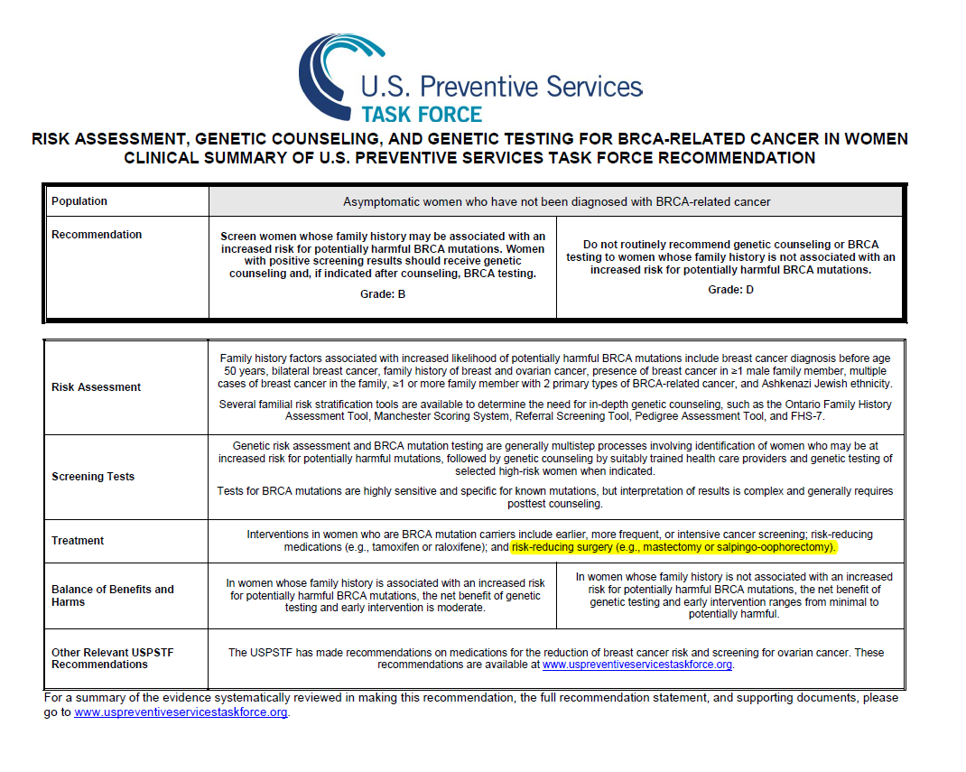
Source:
https://www.uspreventiveservicestaskforce.org/uspstf/recommendation/brca-related-cancer-risk-assessment-genetic-counseling-and-genetic-testing (Clinician Summary in PDF)

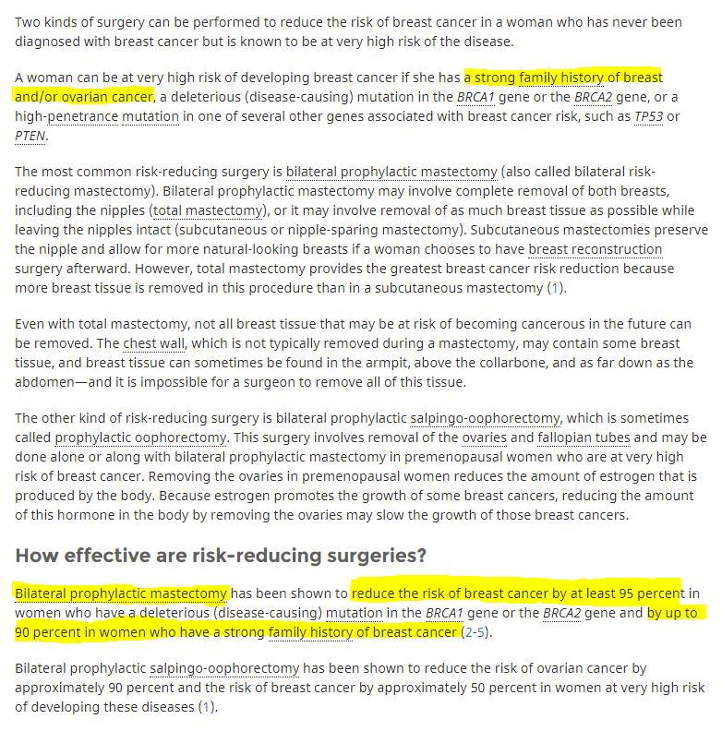
Exhibit B

Source:
https://www.cancer.gov/types/breast/risk-reducing-surgery-fact-sheet#q9
Exhibit C
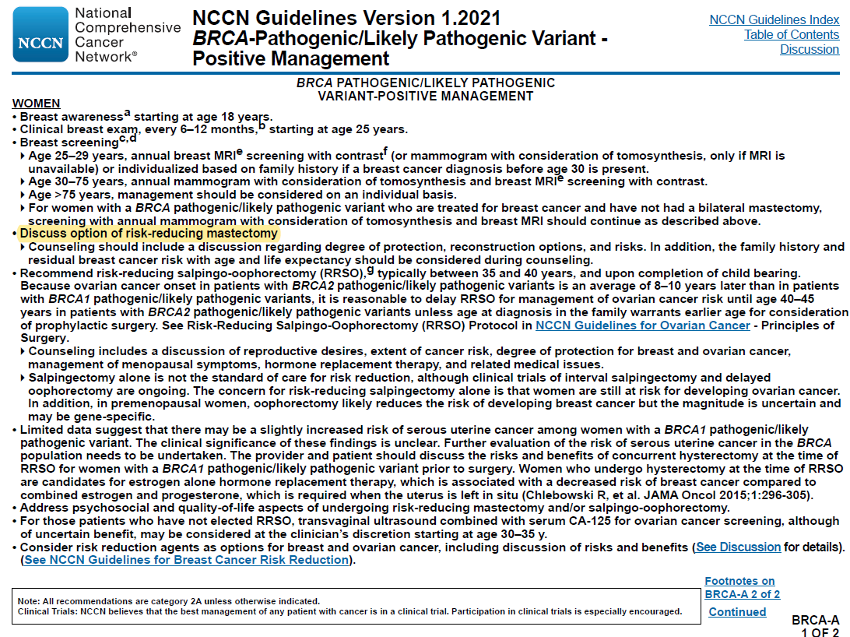
Exhibit D
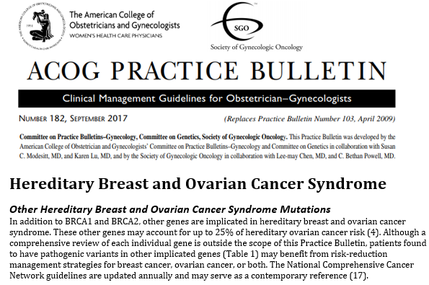
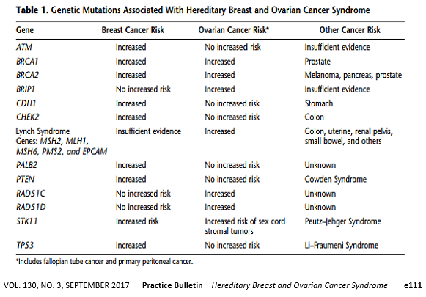

Source:
www.sgo.org/wp-content/uploads/2012/09/PB-182.pdf

Exhibit E

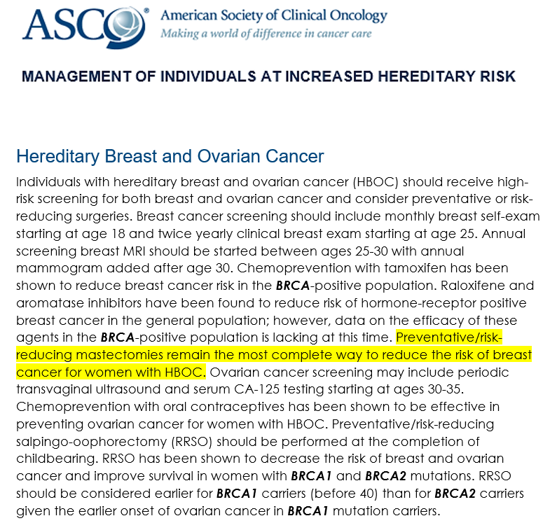
Source:
www.asco.org/practice-guidelines/cancer-care-initiatives/genetics-toolkit/management-individuals-increased

Exhibit F
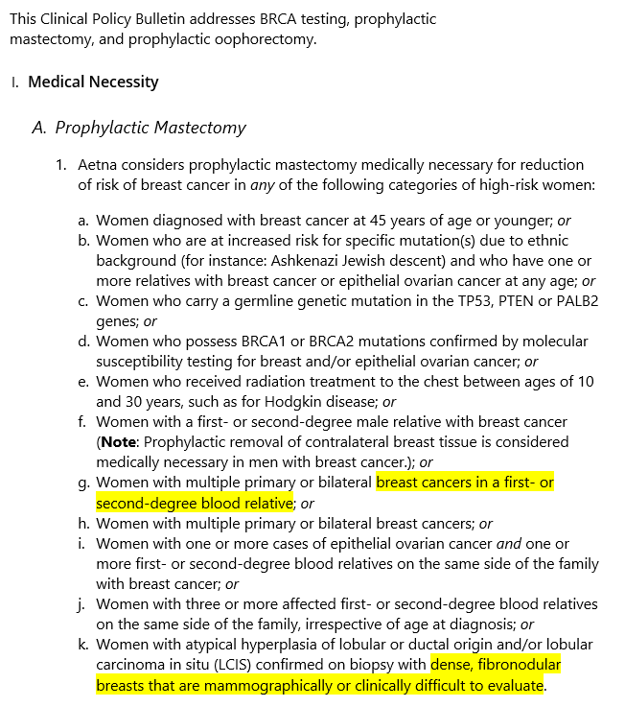

Source: www.aetna.com/cpb/medical/data/200_299/0227.html

Exhibit G
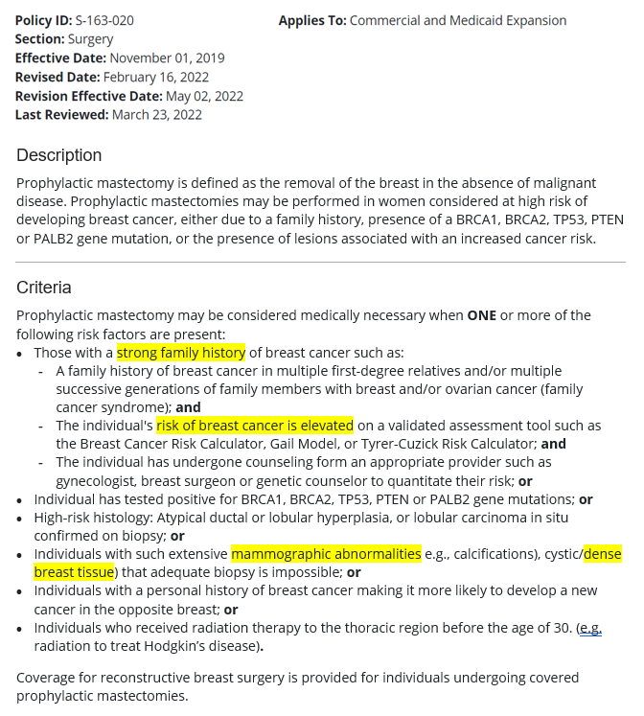

Source:
www.bcbsnd.com/providers/policies-precertification/medical-policy/p/prophylactic-mastectomy

Estimate calculated using the XYZ Model. This is a well-studied, widely available model for predicting breast cancer risk. This model includes the most comprehensive set of variables and is the most sensitive of all the models for detecting risk for breast cancer. It is the only model to account for both personal and extensive family history risk factors
BRCA-Related Cancer: Risk Assessment, Genetic Counseling, and Genetic Testing, August 2019 (https://www.uspreventiveservicestaskforce.org/uspstf/recommendation/brca-related-cancer-risk-assessment-genetic-counseling-and-genetic-testing)
Surgery to Reduce the Risk of Breast Cancer (www.cancer.gov/types/breast/risk-reducing-surgery-fact-sheet)
American Family Physician, Practice Guidelines, ACOG Guidelines for Managing Hereditary Breast and Ovarian Cancer Syndrome (https://www.aafp.org/afp/2009/1215/p1505.html)

