HEALTH INSURER
123 Insurance Way
Anywhere, IL 012345
DATE
RE: Claim # XXXXXXXXXXX
Insured: NAME (ID# XXXXXXXXXXX)
Claimant: NAME (DOB Mo-Day-Year)

To Whom It May Concern:
I am writing to appeal the decision to deny coverage of my [CA125 test and/or transvaginal ultrasound] by [Health Plan Name]. Genetic testing confirmed that I carry a BRCA genetic mutation which puts me at significantly increased risk of breast and ovarian cancer. Average woman have a 1.5% chance of developing ovarian cancer whereas women with a BRCA mutation face up to a 60% lifetime risk of the disease. The U.S. Preventive Services Task Force (USPSTF) BRCA-Related Cancer: Risk Assessment, Genetic Counseling, and Genetic Testing guidelines published in December 2013, give a “Grade: B” to screening women who may be at high risk of breast, ovarian, tubal, or peritoneal cancer. “Women with positive screening results should receive genetic counseling and, if indicated after counseling, BRCA testing.”
The clinical value of identifying people with a BRCA mutation lies in an individual’s ability to access screening and preventive services that lower the risk for breast or ovarian cancer. As such, USPSTF guidelines indicate that “more frequent or intensive cancer screening” is recommended for “women who are BRCA mutation carriers.” [Exhibit A]
Transvaginal ultrasound (TVU) and CA125 testing are currently the only ovarian cancer screening methods available. There is broad consensus among clinical organizations about the benefits of risk-reducing bilateral salpingo-oophorectomy in women at high risk of ovarian cancer, but it is also acknowledged that there are significant side effects from this surgery, i.e. surgical menopause and increased risk of osteoporosis and heart disease. As such, the USPSTF, and multiple other organizations [Exhibit A] including the American Congress of Obstetricians and Gynecologists (ACOG) [Exhibit C], American College of Radiology (ACR) [Exhibit D], and National Comprehensive Cancer Network (NCCN) [Exhibit E] endorse TVU and CA125 for high-risk women like myself, who still have their ovaries.
Many health insurers, including Aetna and Blue Cross, consider ovarian cancer screening medically necessary for high-risk women [Exhibits F and G]. Ovarian screening mechanisms such as CA125 and transvaginal ultrasound are the only options for high-risk women who haven’t surgically removed their ovaries and fallopian tubes. Given my high risk of ovarian cancer, and the poor prognosis if the disease is not diagnosed at an early stage, my medical team and I respectfully request that you cover this important screening.
Thank you for your consideration. Your prompt attention to this appeal is greatly appreciated.
Sincerely,
[Signature]

Exhibit A
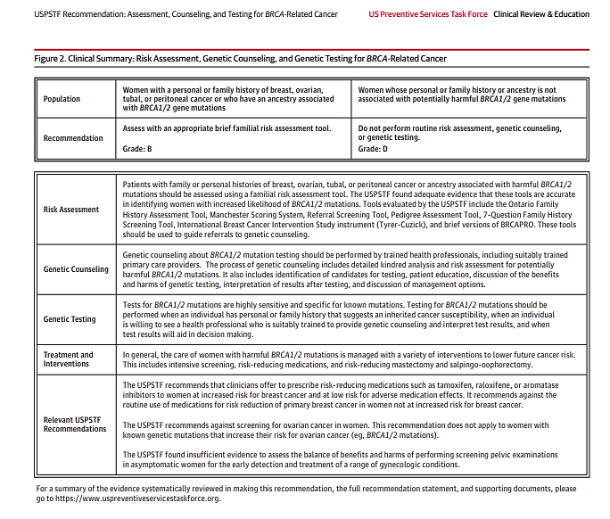

Source:
Figure2 - https://jamanetwork.com/journals/jama/fullarticle/2748515?appid=scweb&alert=article

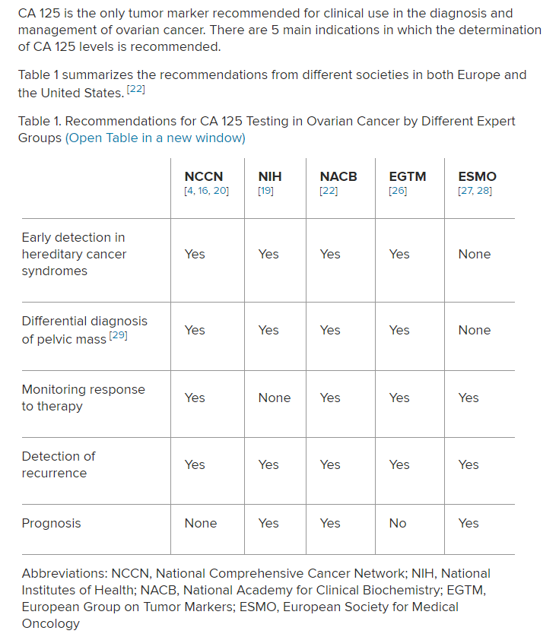
Exhibit B

Source: www.medscape.com/answers/2087557-182632/when-is-serum-ca-125-testing-indicated-in
-ovarian-cancer

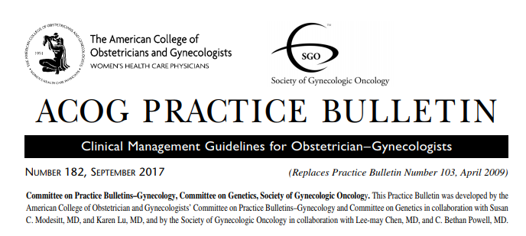
Exhibit C
Hereditary Breast and Ovarian Cancer Syndrome
Summary of Recommendations
- Women with BRCA mutations or who carry another actionable deleterious mutation that is predisposing to breast cancer should be offered risk-reducing bilateral mastectomy.
- Women with BRCA mutations or who carry another actionable deleterious mutation predisposing to ovarian cancer should be offered risk-reducing bilateral salpingo-oophorectomy. The timing of risk-reducing bilateral salpingo-oophorectomy can be individualized based on the particular genetic mutation, the patient’s desires for future childbearing, and family history. Typically, risk-reducing salpingo-oophorectomy is recommended at age 35–40 years for BRCA1 carriers with the highest lifetime risk of ovarian cancer, whereas women with BRCA2 may consider delaying until age 40–45 years because of later onset of ovarian cancer.
- For a risk-reducing bilateral salpingo-oophorectomy, all tissue from the ovaries and fallopian tubes should be removed. Thorough visualization of the peritoneal surfaces with pelvic washings should be performed. Complete, serial sectioning of the ovaries and fallopian tubes is necessary, with microscopic examination for occult cancer.
- In women with BRCA mutations or who have a personal or family history of ovarian cancer, routine ovarian cancer screening with measurement of serum CA 125 level or transvaginal ultrasonography generally is not recommended. Transvaginal ultrasonography or measurement of serum CA 125 level may be reasonable for short-term surveillance in women at high risk of ovarian cancer starting at age 30–35 years until the time they choose to pursue risk-reducing bilateral salpingo-oophorectomy, which is the only proven intervention to reduce ovarian cancer-specific mortality.
- For women aged 25–29 years with known BRCA mutations, recommended breast cancer surveillance includes clinical breast examination every 6–12 months and annual radiographic screening (preferably, MRI with contrast). For women aged 30 years and older with known BRCA mutations or other actionable breast cancer mutations, recommended breast cancer surveillance includes annual mammography and annual breast MRI with contrast, often alternating every 6 months.
e120 Practice Bulletin Hereditary Breast and Ovarian Cancer Syndrome OBSTETRICS & GYNECOLOGY
Source: www.sgo.org/wp-content/uploads/2012/09/PB-182.pdf

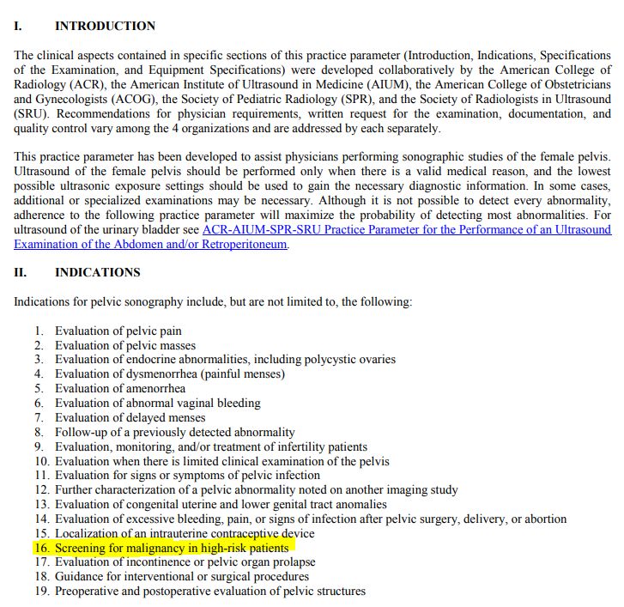
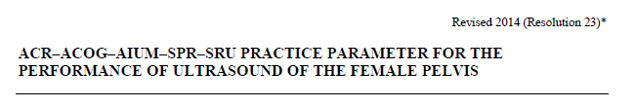
Exhibit D

Source: www.acr.org/-/media/ACR/Files/Practice-Parameters/US-Pelvis.pdf

Exhibit E
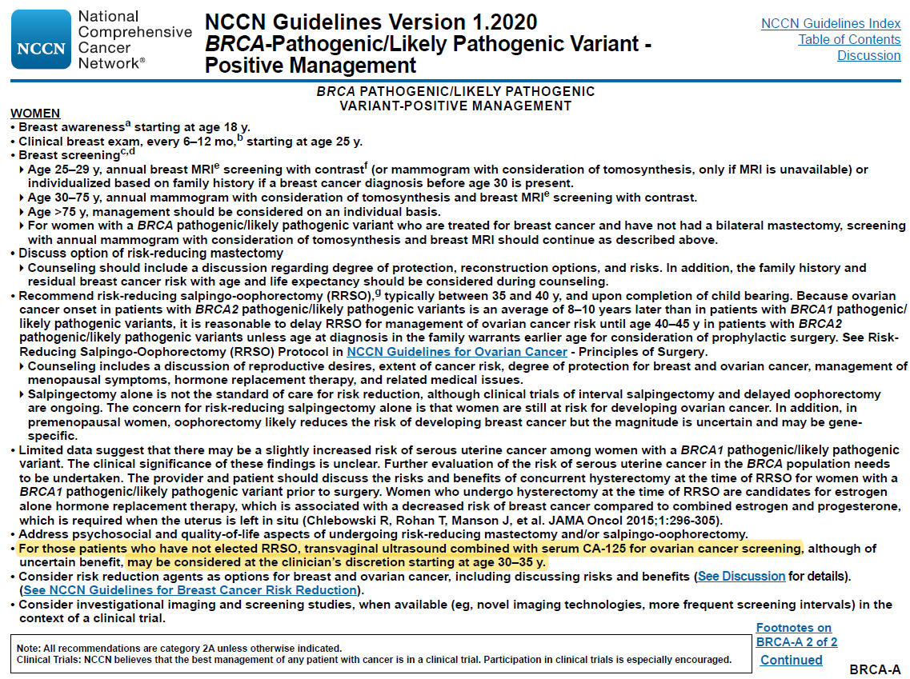

Exhibit F
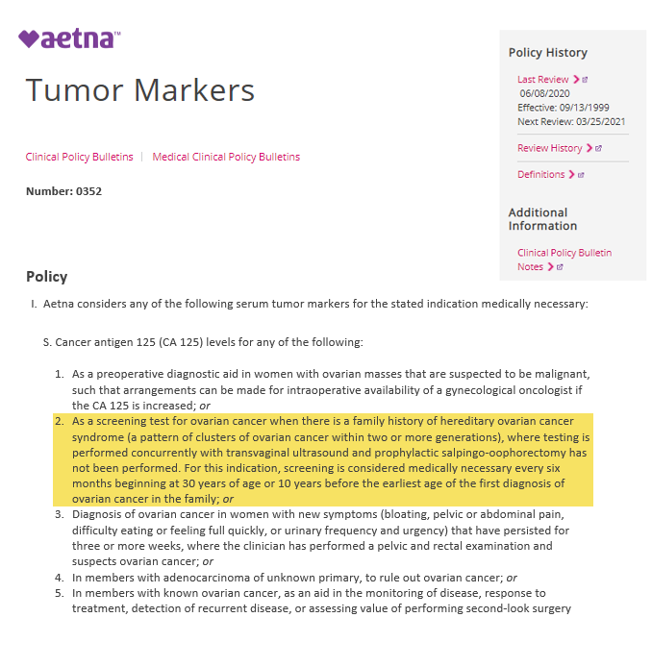
Source: www.aetna.com/cpb/medical/data/300_399/0352.html

Exhibit G
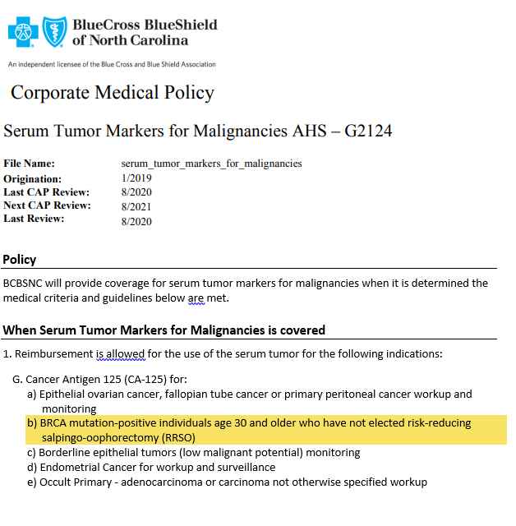

Source: www.bluecrossnc.com/sites/default/files/document/attachment/services/public/pdfs/medicalpolicy/serum_tumor_markers_for_malignancies.pdf

BRCA-Related Cancer: Risk Assessment, Genetic Counseling, and Genetic Testing, December 2013 (http://www.uspreventiveservicestaskforce.org/Page/Document/UpdateSummaryFinal/brca-related-cancer-risk-assessment-genetic-counseling-and-genetic-testing)
Cancer.net, Ovarian Cancer: Statistics (http://www.cancer.net/cancer-types/ovarian-cancer/statistics)

