HEALTH INSURER
123 Insurance Way
Anywhere, IL 012345
DATE
RE: Claim # XXXXXXXXXXX
Insured: NAME (ID# XXXXXXXXXXX)
Claimant: NAME (DOB Mo-Day-Year)

To Whom It May Concern:
I am writing to appeal [Health Plan Name]’s decision to deny coverage of my mammogram, which took place on [date] at [radiology facility]. It is my understanding that [Health Plan Name] covers medically necessary services that are not expressly excluded. [Attach or reference relevant section(s) from health insurer’s Policy or Evidence of Coverage, if possible.]
I recognize that under the Affordable Care Act mammograms may not be a fully covered benefit for women under the age of 40 who have an average risk of developing breast cancer. However, I have a strong family history of breast cancer, including first- and second-degree relatives—which places me at significantly increased risk. While I have not undergone genetic testing, my risk of breast cancer is similar to women who carry and inherited genetic mutation.
The U.S. Preventive Services Task Force notes that women “with a first-degree relative (parent, child, or sibling) with breast cancer may potentially benefit more than average-risk women…from beginning screening mammography” earlier than the general population.
There is broad consensus about the medical necessity of breast screenings for women at increased risk of breast cancer. The National Comprehensive Cancer Network (NCCN) is a professional organization that develops standard-of-care consensus guidelines in cancer. Its practice guidelines for “Breast and/or Ovarian Cancer Syndrome” state that women affected by hereditary breast cancer should have an annual mammogram with consideration of tomosynthesis beginning at age 30.
The American Congress of Obstetricians and Gynecologists (ACOG) states that women aged 30 years and older who are at increased risk of breast cancer… recommended breast cancer surveillance includes annual mammography and annual breast MRI with contrast, often alternating every 6 months. The American Cancer Society [Exhibit A], Society of Breast Imaging and American College of Radiology (ACR) [Exhibit B] recommend breast mammography screenings beginning at age 30 for women with an estimated lifetime risk of 20% or more.
Many health insurers, including Aetna and Cigna, consider screening mammography an appropriate intervention in high-risk women under the age of 40. I meet the criteria outlined in these policies [Exhibit C].
Given my family history and increased risk of breast, I respectfully request that you cover my recent mammogram. The guidelines make it clear that this service is a medically necessary intervention for women at increased risk of breast cancer such as myself.
Thank you for your consideration. Your prompt attention to this matter is greatly appreciated.
Sincerely,
[Signature]
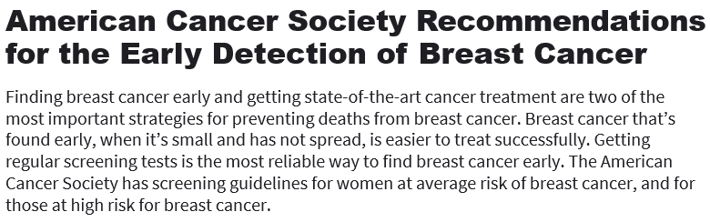
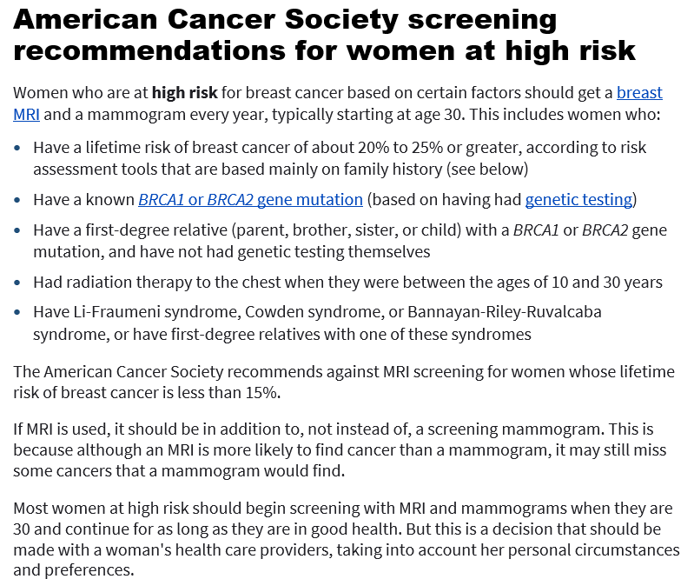
Exhibit A
Last Revised: January 14, 2022
Source:
www.cancer.org/cancer/breast-cancer/screening-tests-and-early-detection/american-cancer-society-recommendations-for-the-early-detection-of-breast-cancer.html

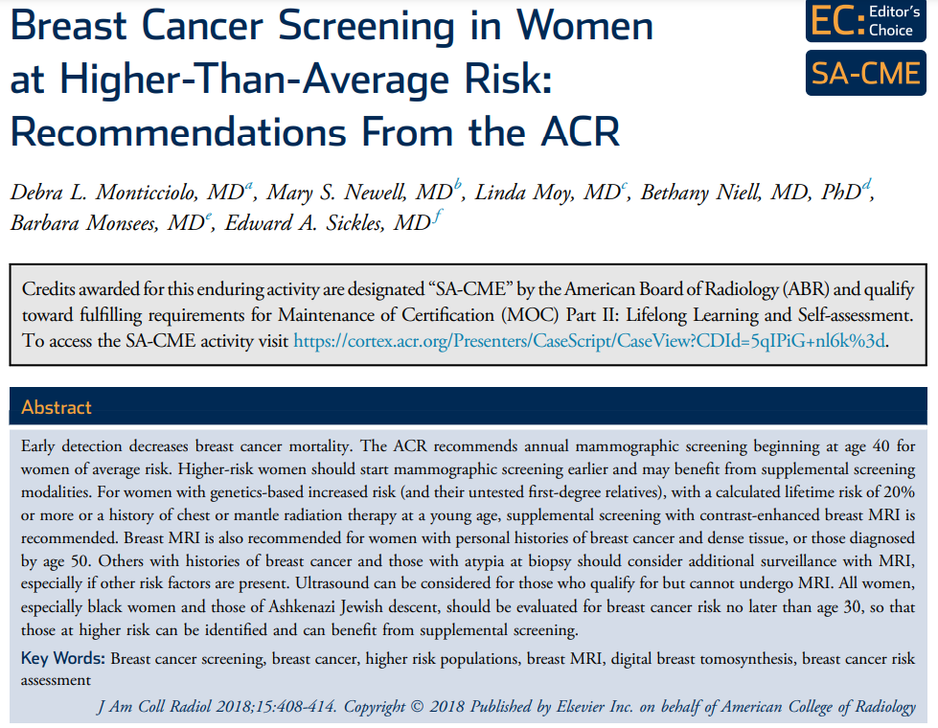
Exhibit B
TAKE-HOME POINTS
- For women with genetics-based increased risk (and their untested first-degree relatives) or with a calculated lifetime risk of 20% or more, DM, with or without DBT, should be performed annually beginning at age 30.
- For women with histories of chest radiation therapy before the age of 30, DM, with or without DBT, should be performed annually beginning at age 25 or 8 years after radiation therapy, whichever is later.
- For women with genetics-based increased risk (and their untested first-degree relatives), histories of chest radiation (cumulative dose of $≥$10 Gy before age 30), or a calculated lifetime risk of 20% or more, breast MRI should be performed annually beginning at age 25 to 30.
- For women with personal histories of breast cancer and dense breast tissue, or those diagnosed before age 50, annual surveillance with breast MRI is recommended.
- For women with personal histories not included in the above, or with ADH, atypical lobular hyperplasia, or LCIS, MRI should be considered, especially if other risk factors are present.
- All women, especially black women and those of Ashkenazi Jewish descent, should be evaluated for breast cancer risk no later than age 30, so that those at higher risk can be identified and can benefit from supplemental screening.
Source:
www.jacr.org/action/showPdf?pii=S1546-1440%2817%2931524-7

Exhibit C

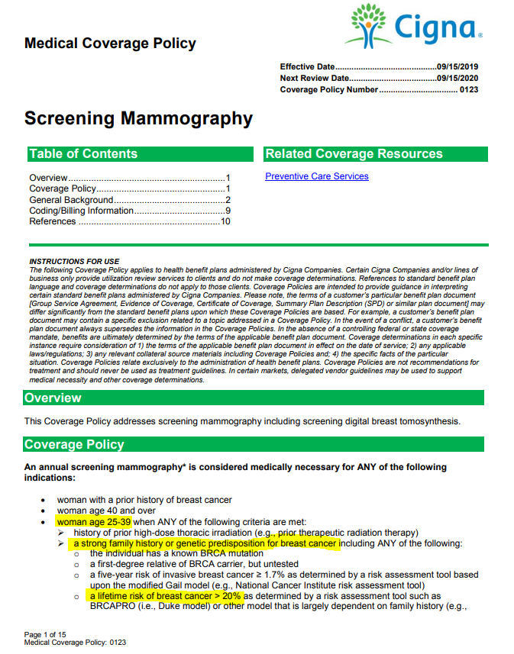
Source: https://cignaforhcp.cigna.com/public/content/pdf/coveragePolicies/medical/mm_0123_coveragepositioncriteria_mammography.pdf

Practice Bulletin Hereditary Breast and Ovarian Cancer Syndrome, VOL. 130, NO. 3, SEPTEMBER 2017, pg. e117 https://www.sgo.org/wp-content/uploads/2012/09/PB-182.pdf

