HEALTH INSURER
123 Insurance Way
Anywhere, IL 012345
DATE
RE: Claim # XXXXXXXXXXX
Insured: NAME (ID# XXXXXXXXXXX)
Claimant: NAME (DOB Mo-Day-Year)

To Whom It May Concern:
I am writing to appeal [Health Plan Name]’s decision to deny coverage of my mammogram, which took place on [date] at [radiology facility]. It is my understanding that [Health Plan Name] covers medically necessary services that are not expressly excluded. [Attach or reference relevant section(s) from health insurer’s Policy or Evidence of Coverage, if possible.]
Under the Patient Protection and Affordable Care Act (ACA), any preventive health service recommended by the U.S. Preventive Services Task Force (USPSTF) with an A or B rating must be covered by most health plans with no copay or coinsurance. The USPSTF BRCA-Related Cancer: Risk Assessment, Genetic Counseling, and Genetic Testing guidelines gives a “Grade: B” to screening women who may be at high risk of breast, ovarian, tubal, or peritoneal cancer. Genetic testing confirmed that I carry an inherited BRCA genetic mutation.
The clinical value of identifying people with a BRCA mutation lies in an individual’s ability to access screening and preventive services that identify cancer at earlier stages or lower the risk of cancer. As such, the USPSTF guidelines indicate that “earlier, more frequent or intensive cancer screening” is recommended for women who are BRCA mutation carriers. [Exhibit A]
While breast screening mammograms are considered an essential health benefit for “average risk” women beginning at age 40, there is broad consensus about the medical necessity of mammograms at younger ages for women at high risk of breast cancer. The National Comprehensive Cancer Network (NCCN) Practice Guidelines for “Genetic/Familial High-Risk Assessment: Breast, Ovarian, and Pancreatic” state that women who carry BRCA genetic mutations should begin “annual mammogram with consideration of tomosynthesis and breast MRI screening with contrast” beginning at age 30. [Exhibit B]
The American Congress of Obstetricians and Gynecologists (ACOG) [Exhibit C], American Cancer Society [Exhibit D], and Society of Breast Imaging and American College for Radiology (ACR) and American Cancer Society [Exhibit E] also recommend annual mammograms for high-risk women and BRCA mutation carriers starting at 25-30 years of age.
Given this evidence of medical necessity, I respectfully request that you reverse the denial of this claim. Additionally, I would like it noted for the future that mammograms are a covered benefit given my high risk of breast cancer. The guidelines make it clear that this service is a necessary intervention for high-risk women such as myself.
Thank you for your consideration. Your prompt attention to this appeal is greatly appreciated.
Sincerely,
[Signature]
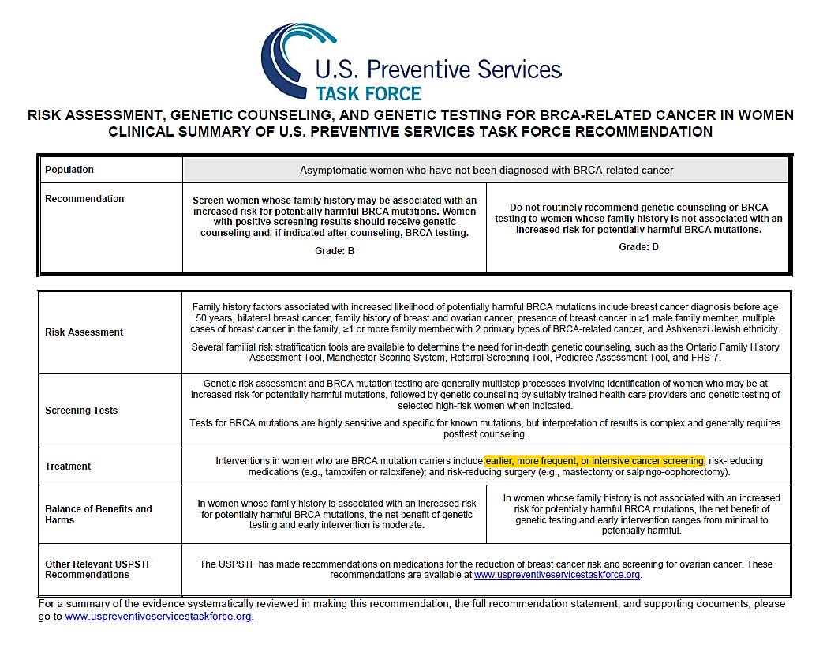
Exhibit A
Exhibit B
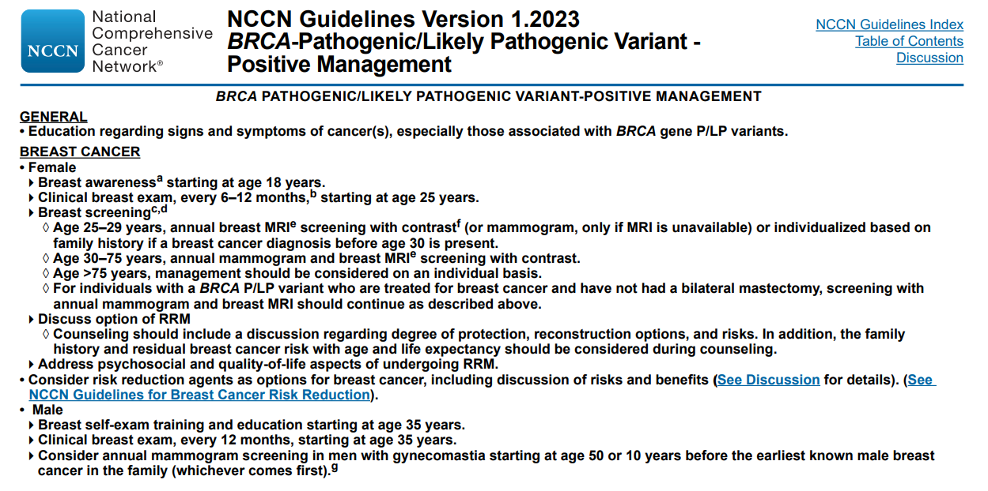
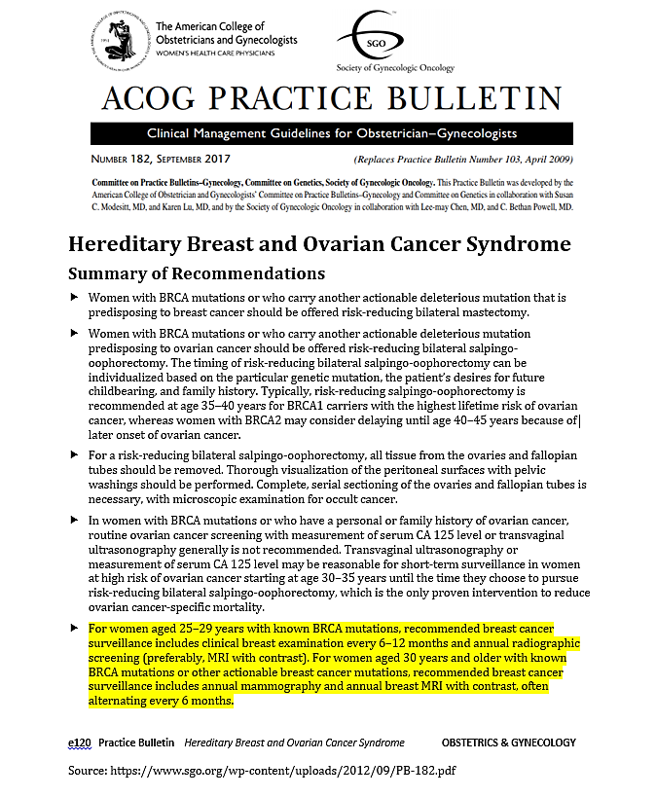
Exhibit C

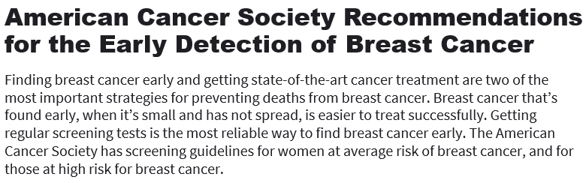
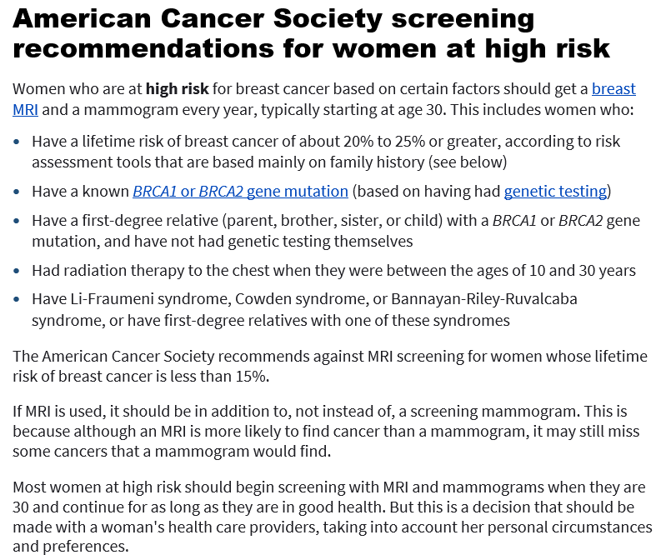
Exhibit D

Last Revised: January 14, 2022
Source:
www.cancer.org/cancer/breast-cancer/screening-tests-and-early-detection/american-cancer-society-recommendations-for-the-early-detection-of-breast-cancer.html
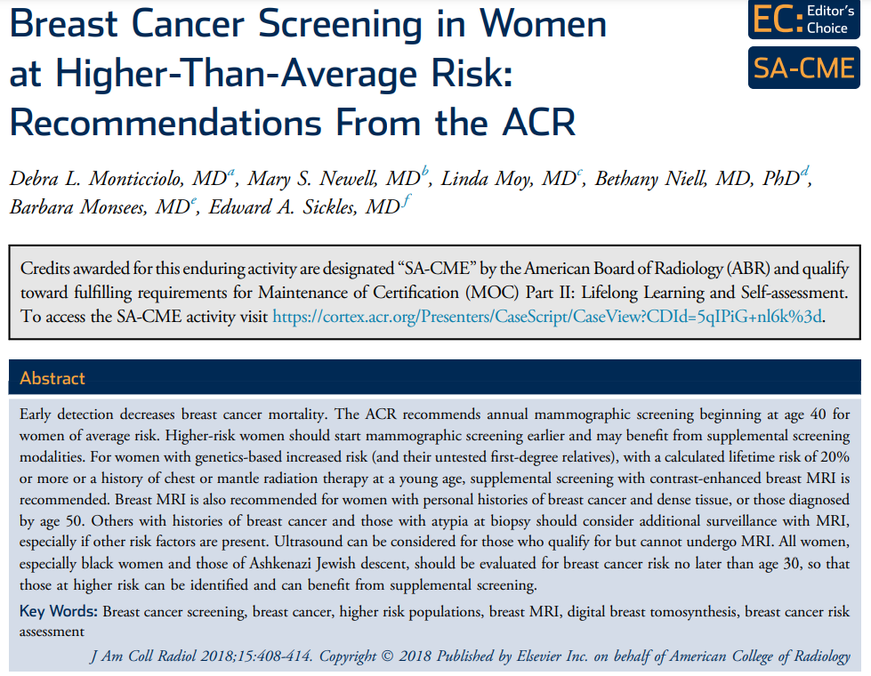
Exhibit E
TAKE-HOME POINTS
- For women with genetics-based increased risk (and their untested first-degree relatives) or with a calculated lifetime risk of 20% or more, DM, with or without DBT, should be performed annually beginning at age 30.
- For women with histories of chest radiation therapy before the age of 30, DM, with or without DBT, should be performed annually beginning at age 25 or 8 years after radiation therapy, whichever is later.
- For women with genetics-based increased risk (and their untested first-degree relatives), histories of chest radiation (cumulative dose of $≥$10 Gy before age 30), or a calculated lifetime risk of 20% or more, breast MRI should be performed annually beginning at age 25 to 30.
- For women with personal histories of breast cancer and dense breast tissue, or those diagnosed before age 50, annual surveillance with breast MRI is recommended.
- For women with personal histories not included in the above, or with ADH, atypical lobular hyperplasia, or LCIS, MRI should be considered, especially if other risk factors are present.
- All women, especially black women and those of Ashkenazi Jewish descent, should be evaluated for breast cancer risk no later than age 30, so that those at higher risk can be identified and can benefit from supplemental screening.

Source:
www.jacr.org/action/showPdf?pii=S1546-1440%2817%2931524-7

NCCN Clinical Practice Guidelines in Oncology: Genetic/Familial High-Risk Assessment: Breast, Ovarian, and Pancreatic, Version 1.2023 — September 7, 2022 (www.nccn.org/professionals/physician_gls/pdf/genetics_bop.pdf)

