HEALTH INSURER
123 Insurance Way
Anywhere, IL 012345
DATE
RE: Claim # XXXXXXXXXXX
Insured: NAME (ID# XXXXXXXXXXX)
Claimant: NAME (DOB Mo-Day-Year)

To Whom It May Concern:
I am writing to appeal [Health Plan Name]’s decision to deny coverage of my breast screening MRI, which took place on [date] at [radiology facility]. It is my understanding that [Health Plan Name] covers medically necessary services that are not expressly excluded. [Attach or reference relevant section(s) from health insurer’s Policy or Evidence of Coverage, if possible.]
I recognize that breast MRI is not a covered benefit for women considered to be at low- or average- risk of developing breast cancer. However, I carry a [add your genetic mutation or risk factor/mutation here] which places me at significantly increased risk for breast cancer. My medical team has indicated that annual breast MRI is medically indicated for risk management.
There is broad consensus about the medical necessity of breast screening MRI for women at high risk of breast cancer. The National Comprehensive Cancer Network (NCCN) is a professional organization that develops standard-of-care consensus guidelines in cancer. Its Practice Guidelines for “Genetic/Familial High-Risk Assessment: Breast, Ovarian, and Pancreatic” states that women affected by hereditary breast and ovarian cancer syndromes (i.e. [insert name of gene here if you have a mutation in one of the following: ATM, CDH1, CHEK2, NBN, NF1, PALB2] mutation carriers) should have an annual breast screening MRI with contrast. Other mutations such as Lynch Syndrome should be managed based on family history. [Exhibit A]
The American Cancer Society [Exhibit B], Society of Breast Imaging and American College of Radiology (ACR) [Exhibit C], and American Congress of Obstetricians and Gynecologists (ACOG) [Exhibit D] also recommend annual breast MRI screening for women with an estimated lifetime risk of 20% or more, and those with inherited genetic mutations associated with moderate- to high-risk of breast cancer.
Given this evidence of medical necessity, I respectfully request that you reverse the denial of this claim. Additionally, I would like it noted for the future that annual breast screening MRI is a covered benefit given my high risk of breast cancer. The guidelines make it clear that this service is a necessary intervention for women at increased risk of breast cancer such as myself.
Thank you for your consideration. Your prompt attention to this matter is greatly appreciated.
Sincerely,
[Signature]

Exhibit A
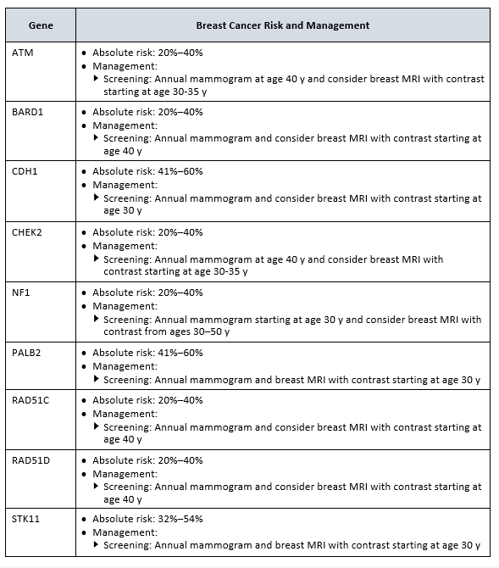

Exhibit B
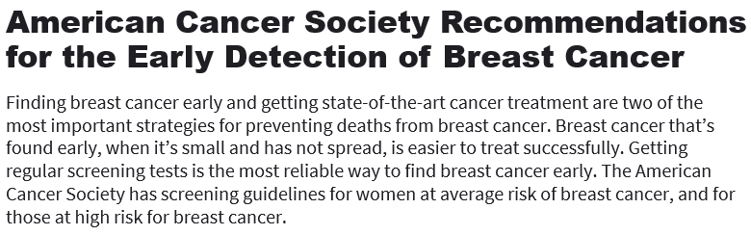
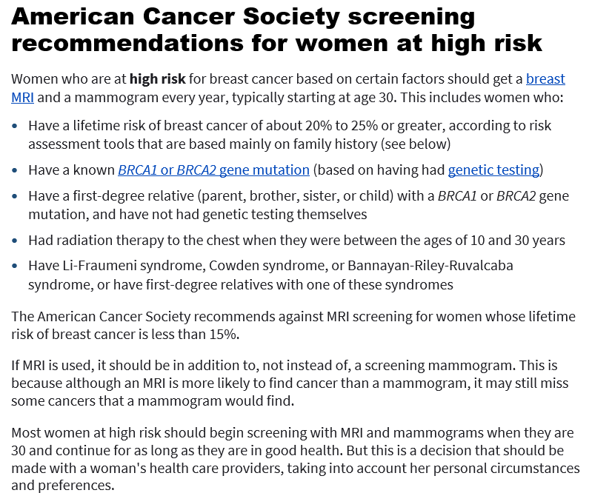
Last Revised: January 14, 2022
Source:
www.cancer.org/cancer/breast-cancer/screening-tests-and-early-detection/american-cancer-society-recommendations-for-the-early-detection-of-breast-cancer.html
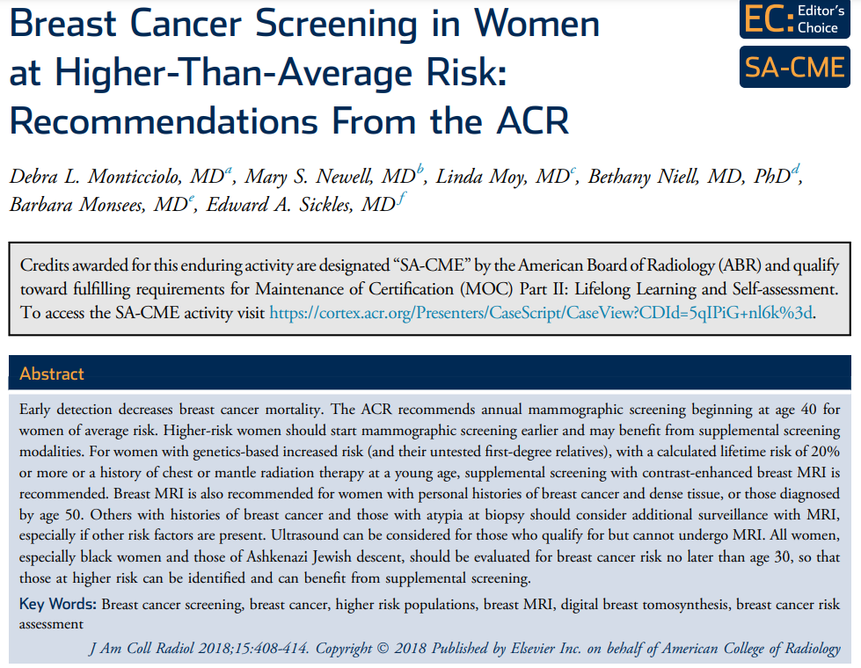
Exhibit C
TAKE-HOME POINTS
- For women with genetics-based increased risk (and their untested first-degree relatives) or with a calculated lifetime risk of 20% or more, DM, with or without DBT, should be performed annually beginning at age 30.
- For women with histories of chest radiation therapy before the age of 30, DM, with or without DBT, should be performed annually beginning at age 25 or 8 years after radiation therapy, whichever is later.
- For women with genetics-based increased risk (and their untested first-degree relatives), histories of chest radiation (cumulative dose of $≥$10 Gy before age 30), or a calculated lifetime risk of 20% or more, breast MRI should be performed annually beginning at age 25 to 30.
- For women with personal histories of breast cancer and dense breast tissue, or those diagnosed before age 50, annual surveillance with breast MRI is recommended.
- For women with personal histories not included in the above, or with ADH, atypical lobular hyperplasia, or LCIS, MRI should be considered, especially if other risk factors are present.
- All women, especially black women and those of Ashkenazi Jewish descent, should be evaluated for breast cancer risk no later than age 30, so that those at higher risk can be identified and can benefit from supplemental screening.

Source:
www.jacr.org/action/showPdf?pii=S1546-1440%2817%2931524-7

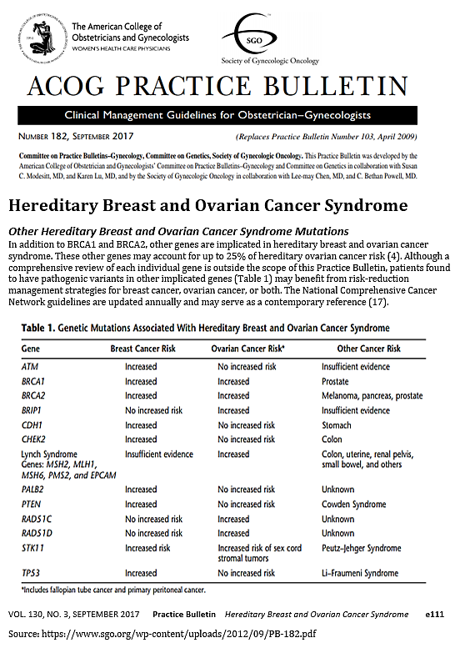
Exhibit D

NCCN Clinical Practice Guidelines in Oncology: Genetic/Familial High-Risk Assessment: Breast, Ovarian, and Pancreatic, Version 1.2023 — September 7, 2022 (www.nccn.org/professionals/physician_gls/pdf/genetics_bop.pdf)

