HEALTH INSURER
123 Insurance Way
Anywhere, IL 012345
DATE
RE: Claim # XXXXXXXXXXX
Claimant: NAME (ID# and DOB: Mo-Day-Year)
To Whom It May Concern:
I am writing to appeal [Health Plan Name]’s decision to deny coverage of my colonoscopy, which took place on [date] at [facility]. It is my understanding that [Health Plan Name] covers medically necessary services that are not expressly excluded. [Attach or reference relevant section(s) from health insurer’s Policy or Evidence of Coverage, if possible.]
I recognize that under the Affordable Care Act screening colonoscopies may not be a fully covered benefit for people under the age of 50 who have an average risk of developing colorectal cancer (CRC). However, I have a Lynch syndrome genetic mutation, which places me in the high-risk category. Hereditary cancers tend to occur at younger ages so earlier screening is recommended. This reduces colon cancer mortality by as much as 80%.
The U.S. Preventive Services Task Force (USPSTF) Colorectal Cancer Screening guidelines state, “This recommendation applies to asymptomatic adults 45 years and older who are at average risk of colorectal cancer and who do not have a family history of known genetic disorders that predispose them to a high lifetime risk of colorectal cancer.” The guidelines go on to note, “The USPSTF did not specifically review the evidence on screening in populations at increased risk; however, other professional organizations recommend that patients with a family history of colorectal cancer…be screened more frequently starting at a younger age, and with colonoscopy.”
There is broad consensus about the medical necessity of earlier, more frequent colorectal cancer screening for those at increased risk. The National Cancer Institute provides a table of Lynch Syndrome CRC screening practice guidelines for health care professionals, all of which indicate that colonoscopies should start age 20-25, or earlier based on family history [Exhibit A].
The National Comprehensive Cancer Network (NCCN) Practice Guidelines “Genetic/Familial High-Risk Assessment: Colorectal” hereditary/ high-risk CRC category includes, “individuals who have…personal or family history of polyposis; or individuals with HNPCC/Lynch syndrome.” NCCN and the Multi-Society Task Force on Colorectal Cancer—comprised of the American College of Gastroenterology, the American Gastroenterological Association, and The American Society for Gastrointestinal Endoscopy—recommendations align [Exhibits B and C].
Many health insurers, including Cigna and Blue Cross Blue Shield, cover screening colonoscopies for high-risk individuals under the age of 45 [Exhibits D and E]. Given my high risk of CRC, I respectfully request that you cover my colonoscopies. The guidelines make it clear that this is a medically necessary intervention for people with Lynch syndrome, such as myself.
Thank you for your consideration. Your prompt attention to this matter is greatly appreciated.
Sincerely,
[Signature]
Exhibit A
Genetics of Colorectal Cancer (PDQ®)–Health Professional Version
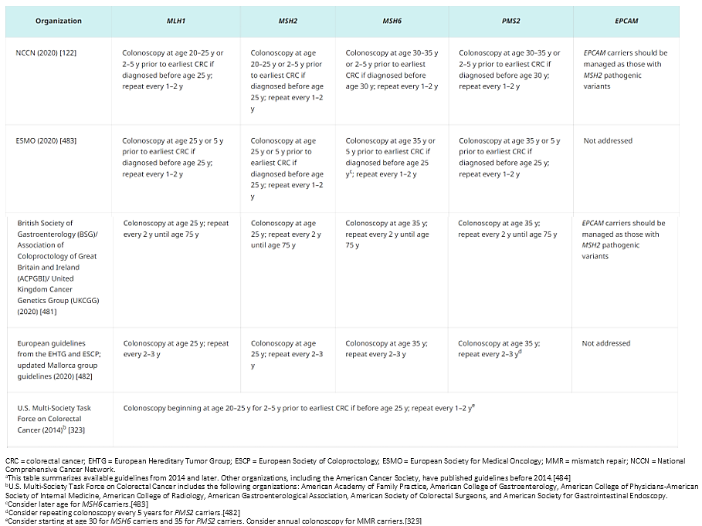
Source: www.cancer.gov/types/colorectal/hp/colorectal-genetics-pdq#_2986_toc
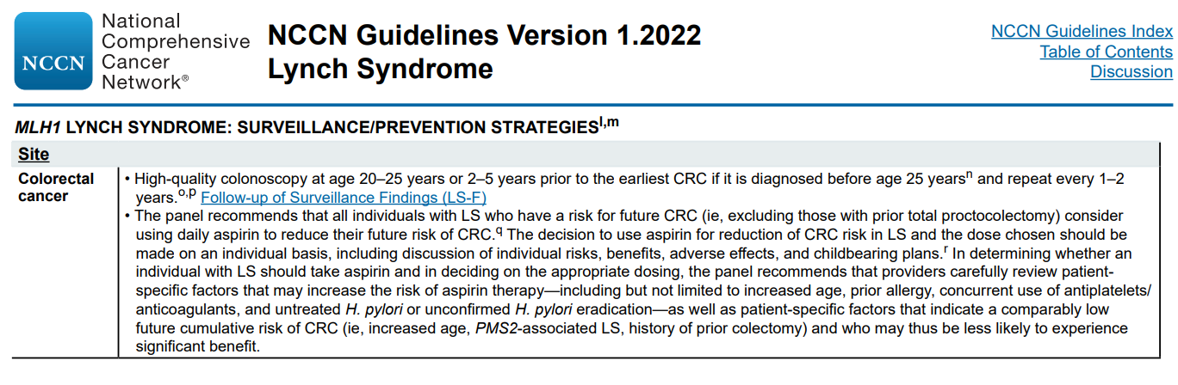
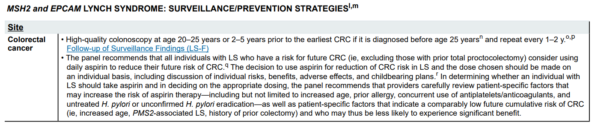
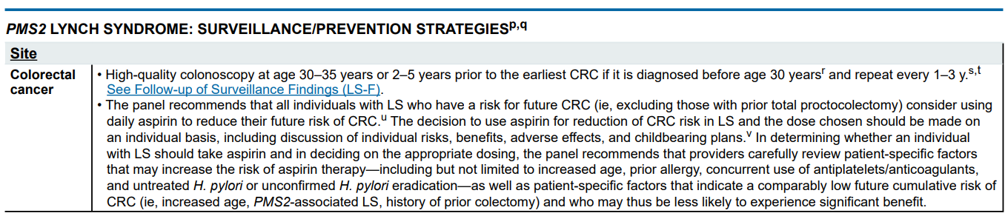
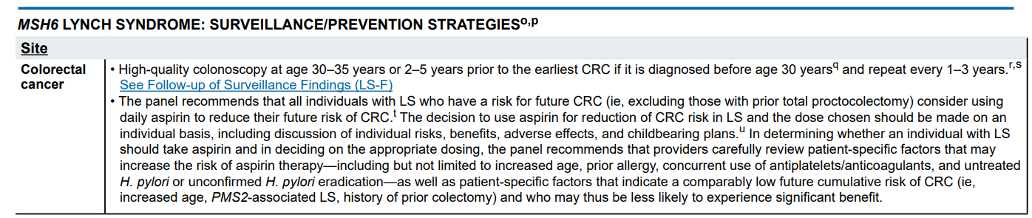
Exhibit B

Exhibit C

Guidelines on Genetic Evaluation and Management of Lynch Syndrome: A Consensus Statement by the US Multi-Society Task Force on Colorectal Cancer
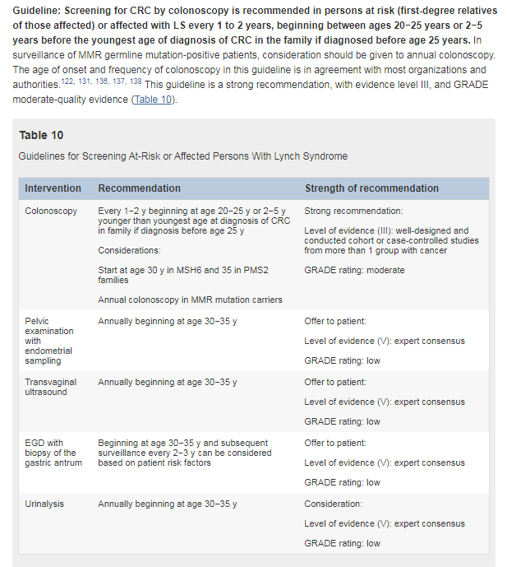
Source: American Journal of Gastroenterology, August 2014 - Volume 109 - Issue 8 - p 1159-1179
doi: 10.1038/ajg.2014.186

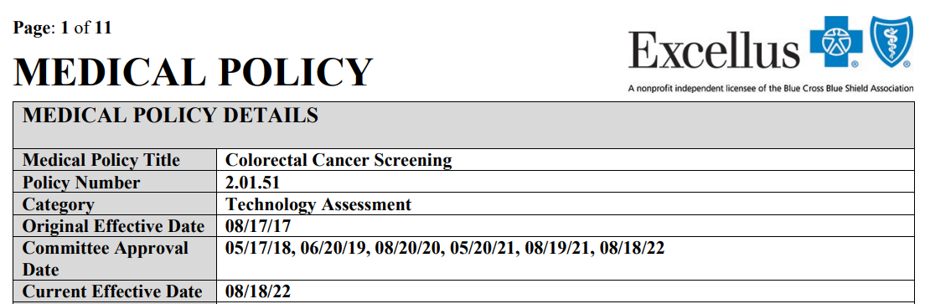
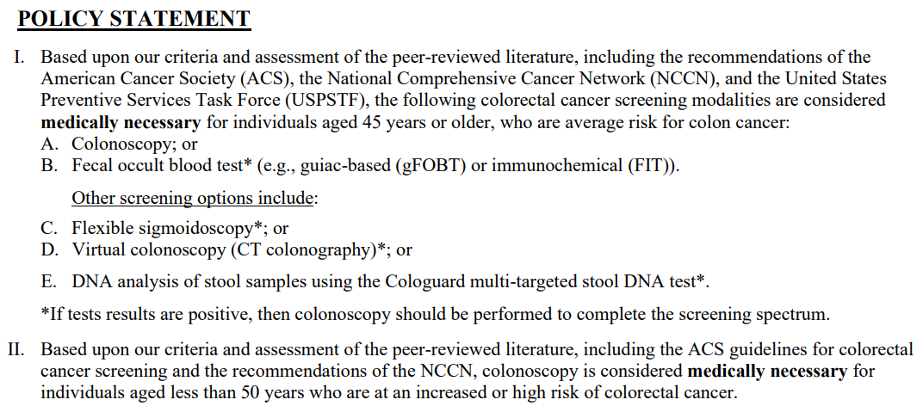
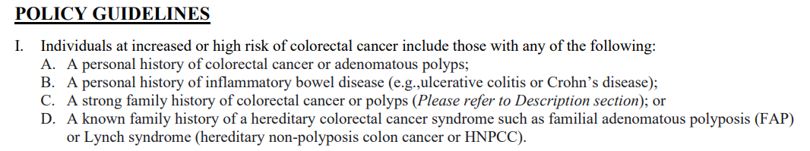
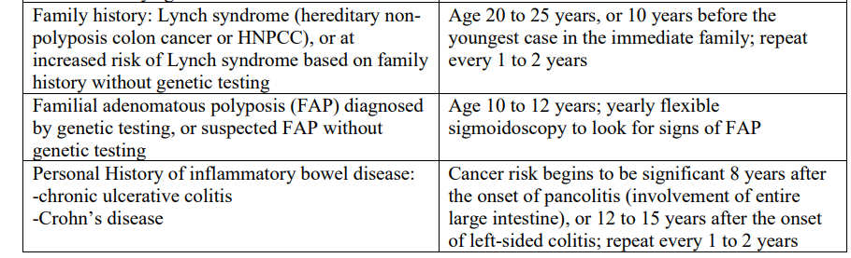
Exhibit D

Source: www.excellusbcbs.com/documents/20152/127121/EXC-PRV-Colorectal+Cancer+Screening.pdf/5e66ab16-e56e-c725-23c8-5ebc289243d2?t=1583514167361

Exhibit D
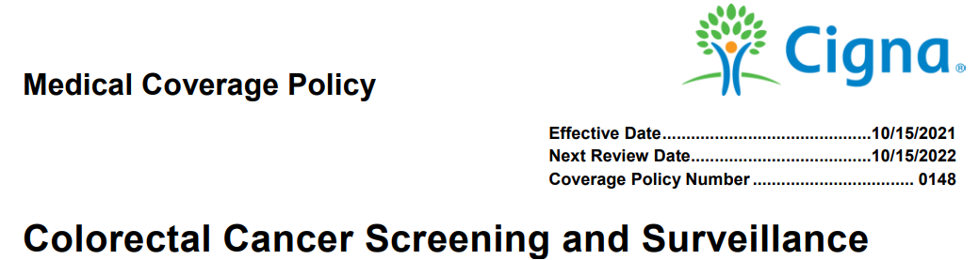
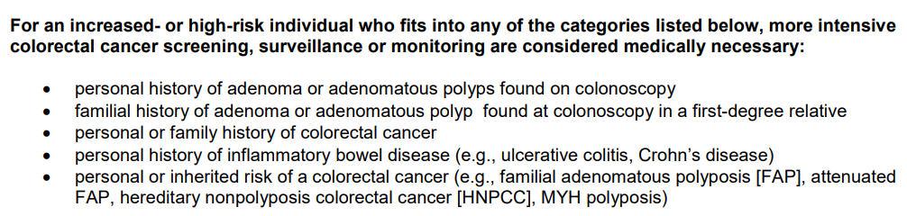

Source: https://static.cigna.com/assets/chcp/pdf/coveragePolicies/medical/mm_0148_coveragepositioncriteria_colorectal_cancer_screening.pdf

U.S. Preventive Services Task Force Final Recommendation Statement, Colorectal Cancer: Screening - www.uspreventiveservicestaskforce.org/uspstf/recommendation/colorectal-cancer-screening#fullrecommendationstart

