HEALTH INSURER
123 Insurance Way
Anywhere, IL 012345

DATE

RE: Claim # XXXXXXXXXXX
Insured: NAME (ID# XXXXXXXXXXX)
Claimant: NAME (DOB Mo-Day-Year)

To Whom It May Concern:
I am writing to appeal [Health Plan Name]’s decision to deny coverage of genetic [counseling and/or testing] for a BRCA genetic mutation, which took place on [date] at [facility or physician’s office]. I recently learned that my [mother, father, sister, brother…] carries an inherited BRCA mutation. As a result, it was recommended that family members get tested.
Men with BRCA mutations have up to a 40% lifetime risk for prostate cancer, which is much higher than average-risk men. The lifetime risk of developing male breast cancer for BRCA mutation carriers is estimated at up to 10%, compared with a risk of 0.1% in the general population. Research also shows that men with these mutations also have increased risk of pancreatic cancer and melanoma.
There is broad consensus about the medical benefits of genetic counseling and testing to identify individuals at increased risk of cancer. The National Comprehensive Cancer Network (NCCN) is a professional organization that develops standard-of-care consensus guidelines in cancer. Its practice guidelines for “BRCA-Related Breast and/or Ovarian Cancer Syndrome” reiterate the need to identify individuals—including men—affected by hereditary cancer syndromes via genetic testing, and outline the recommended screening and preventive services for high-risk individuals.
The clinical value of identifying people with a BRCA mutation lies in an individual’s ability to access screening and preventive services that lower the risk of cancer, or diagnose the disease at an earlier stage when it is more easily treated. Research shows that the relative risks of developing breast cancer are highest for BRCA+ men in their 30s and 40s. As such, knowledge of a germline BRCA mutation is crucial in determining appropriate screening and risk management.
Similarly, BRCA mutation status is recognized as an independent prognostic prostate cancer risk factor and marker of a more aggressive tumor and a poorer overall survival. Recent research supports increased screening and use of PSA tests in men with BRCA mutations. Preliminary results from the IMPACT study “support the use of targeted prostate-specific antigen screening based on BRCA genotype and show that this yields a high proportion of aggressive disease.”
Accordingly, NCCN Guidelines state that men with BRCA mutations should have an annual clinical breast exam starting at age 35, prostate cancer screening beginning at age 40, and other cancer screenings as appropriate [Exhibits A and B]. An expert consensus conference convened in 2017 issued guidelines supporting BRCA testing in men and recommends that those with BRCA2 mutations have a “baseline PSA at age 40 years or 10 years prior to youngest PCA diagnosed in family” followed by yearly screening., The American Cancer Society recommends prostate cancer screening starting at age 40 for men in the highest risk category, such as myself [Exhibit C].
Numerous group health insurance plans recognize the value of BRCA testing in unaffected men with a first- or second-degree relative with a known BRCA mutation [Exhibit D]. Clinical guidelines and evidence from the NCCN, American Urological Association, National Society of Genetic Counselors, and other professional organizations advocate for testing unaffected men with a known mutation in the family.
I respectfully request that you approve reimbursement for my BRCA [counseling and/or testing]. Thank you for your consideration. Your prompt attention to this matter is greatly appreciated.
Sincerely,
[Signature]

Exhibit A
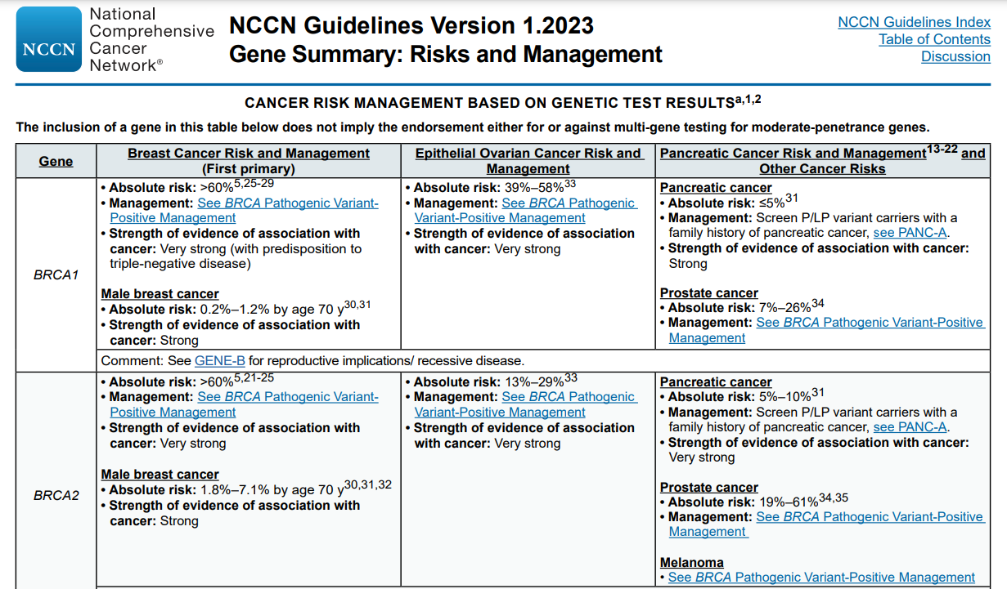
Exhibit B
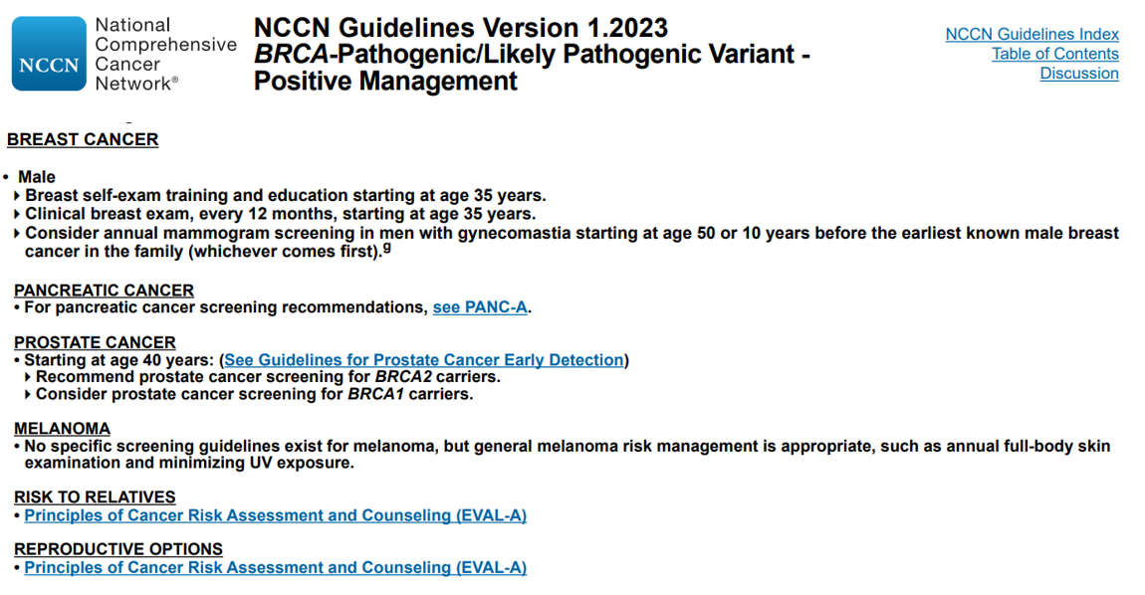
Exhibit C
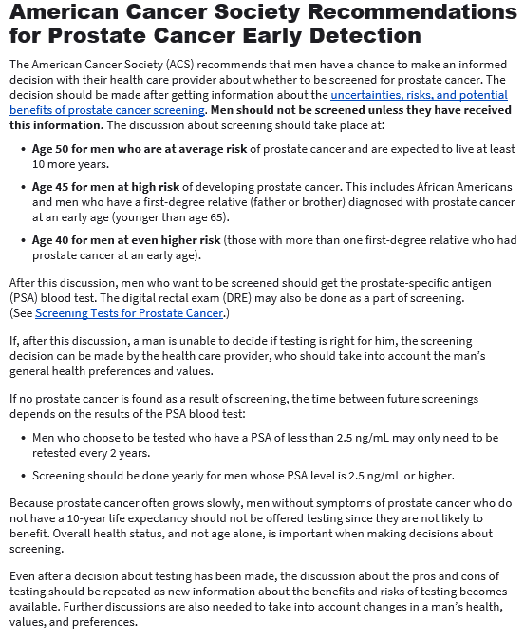

Last Revised: April 23, 2022

Source:
www.cancer.org/cancer/prostate-cancer/early-detection/acs-recommendations.html
Exhibit D
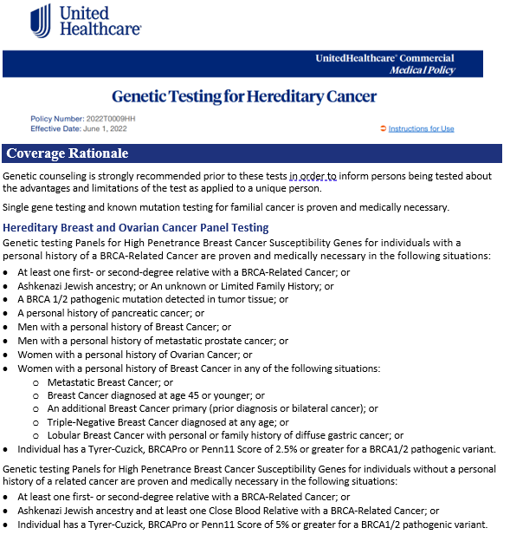
Source:
www.uhcprovider.com/content/dam/provider/docs/public/policies/comm-medical-drug/genetic-testing-hereditary-cancer.pdf

JCO, Prediction of Breast and Prostate Cancer Risks in Male BRCA1 and BRCA2 Mutation Carriers Using Polygenic Risk Scores, http://ascopubs.org/doi/full/10.1200/JCO.2016.69.4935
National Cancer Institute, BRCA Mutations: Cancer Risk and Genetic Testing, www.cancer.gov/about-cancer/causes-prevention/genetics/brca-fact-sheet
Breast Cancer Risk Among Male BRCA1 and BRCA2 Mutation Carriers, https://academic.oup.com/jnci/article/99/23/1811/993419
Targeted prostate cancer screening in BRCA1 and BRCA2 mutation carriers to detect clinically significant disease: Results from the initial screening round of the IMPACT study, https://meetinglibrary.asco.org/record/90940/abstract
JCO, Role of Genetic Testing for Inherited Prostate Cancer Risk: Philadelphia Prostate Cancer Consensus Conference 2017, http://ascopubs.org/doi/full/10.1200/JCO.2017.74.1173
Renal & Urology News, Prostate Cancer Advisor, Prostate Cancer Gene Testing Guidelines Issued, www.renalandurologynews.com/prostate-cancer/prostate-cancer-gene-testing-guidelines-issued/article/738076/

