HEALTH INSURER
123 Insurance Way
Anywhere, IL 012345
DATE
RE: Claim # XXXXXXXXXXX
Insured: NAME (ID# XXXXXXXXXXX)
Claimant: NAME (DOB Mo-Day-Year)
To Whom It May Concern:
I am writing to appeal [Insurer’s] decision to deny coverage of my breast reconstruction revision surgery on [date]. The Women’s Health and Cancer Rights Act (WHCRA) requires most group and individual health plans to pay for breast reconstruction following mastectomy. The laws stipulates that any woman undergoing a mastectomy is entitled to “all stages of reconstruction of the breast on which the mastectomy was performed, surgery and reconstruction of the other breast to produce a symmetrical appearance, prostheses and treatment of physical complications of the mastectomy, including lymphedema.” [Exhibits A and B]
Breast reconstruction following a mastectomy can significantly affect a woman’s body image, self-esteem, and quality of life. The WHRCA exists to help ensure that patients have a choice and some sense of control when they face a mastectomy, allowing them to work with their health care providers to choose the type of reconstruction best suited for them. The law also requires coverage of care related to “physical complications of all stages of the mastectomy.”
Unfortunately, I experienced complications with my breast reconstruction. [Provide relevant details.] Medical experts advised me to [outline recommendations] in order to resolve these issues. Given that the WHRCA requires coverage of care related to physical complications related to a mastectomy, I expected [Insurer] to cover this surgery.
Breast reconstruction following mastectomy, including revisions, is widely considered reasonable and necessary. Every woman’s body is unique so the process is not “one size fits all.” To accommodate these differences, most health insurers cover various types and phases of post-mastectomy reconstruction [Exhibits G and H]. No woman wants to undergo a mastectomy—or to encounter complications with her breast reconstruction—but a satisfactory outcome is not too much to ask.
Under the WHRCA, [Insurer] should cover reconstructive revisions and/or replacement of breast implants as needed. I respectfully request coverage of my reconstructive revision surgery based on the evidence provided herein.
Thank you for your consideration. Your prompt attention to this appeal is greatly appreciated.
Sincerely,
[Signature]
Exhibit A
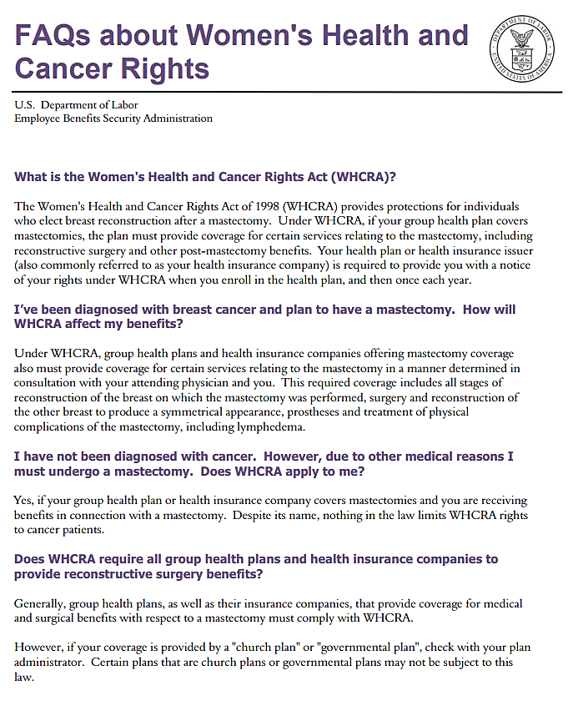
Source: www.dol.gov/sites/default/files/ebsa/about-ebsa/our-activities/resource-center/faqs/whcra.pdf
Exhibit B

Women's Health and Cancer Rights Act (WHCRA)
The Women's Health and Cancer Rights Act of 1998 (WHCRA) is a federal law that provides protections to patients who choose to have breast reconstruction in connection with a mastectomy.
If WHCRA applies to you and you are receiving benefits in connection with a mastectomy and you elect breast reconstruction, coverage must be provided for:
- All stages of reconstruction of the breast on which the mastectomy has been performed;
- Surgery and reconstruction of the other breast to produce a symmetrical appearance; and
- Prostheses and treatment of physical complications of all stages of the mastectomy, including lymphedema.
This law applies to two different types of coverage:
- Group health plans (provided by an employer or union);
- Individual health insurance policies (not based on employment).
Group health plans can either be “insured” plans that purchase health insurance from a health insurance issuer, or “self-funded” plans that pay for coverage directly. How they are regulated depends on whether they are sponsored by private employers, or state or local (“non-federal”) governmental employers. Private group health plans are regulated by the Department of Labor. State and local governmental plans, for purposes of WHCRA, are regulated by CMS. If any group health plan buys insurance, the insurance itself is regulated by the State’s insurance department.
Contact your employer’s plan administrator to find out if your group coverage is insured or self-funded, to determine what entity or entities regulate your benefits.
Health insurance sold to individuals (not through employment) is primarily regulated by State insurance departments.
WHCRA requires group health plans and health insurance companies (including HMOs), to notify individuals regarding coverage required under the law. Notice about the availability of these mastectomy-related benefits must be given:
- To participants and beneficiaries of a group health plan at the time of enrollment, and to policyholders at the time an individual health insurance policy is issued; and
- Annually to group health plan participants and beneficiaries, and to policyholders of individual policies.
Contact your State's insurance department to find out whether additional state law protections apply to your coverage if you are in an insured group health plan or have individual (non-employment based) health insurance coverage.
WHCRA does not apply to high risk pools since the pool is a means by which individuals obtain health coverage other than through health insurance policies or group health plans.
WHCRA does NOT require group health plans or health insurance issuers to cover mastectomies in general. If a group health plan or health insurance issuer chooses to cover mastectomies, then the plan or issuer is generally subject to WHCRA requirements.
Note: A non-Federal governmental employer that provides self-funded group health plan coverage to its employees (coverage that is not provided through an insurer) may elect to exempt its plan (opt out) from the requirements of WHCRA by following the “Procedures & Requirements for HIPAA Exemption Election” posted on the Self-Funded Non-Federal Governmental Plans webpage at http://cms.gov/cciio/resources/files/hipaa_exemption_election_instructions_04072011.html. This includes a requirement to issue a notice of opt-out to enrollees at the time of enrollment and on an annual basis. For a list of plans that have opted out of WHCRA, go to http://cms.gov/cciio/resources/other/index.html#nonfed and click on “List of HIPAA Opt-out Elections for Self-funded Non-Federal Governmental Plans.”
If you have concerns about your plan’s compliance with WHCRA, contact our help line at 1-877-267-2323 extension 6-1565 or at phig@cms.hhs.gov.
Source: www.cms.gov/CCIIO/Programs-and-Initiatives/Other-Insurance-Protections/whcra_factsheet.html
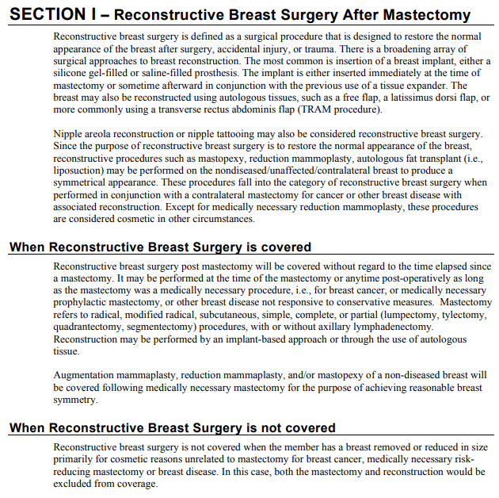
Exhibit C
Source: www.bluecrossnc.com/sites/default/files/document/attachment/services/public/pdfs/medicalpolicy/breast_surgeries.pdf

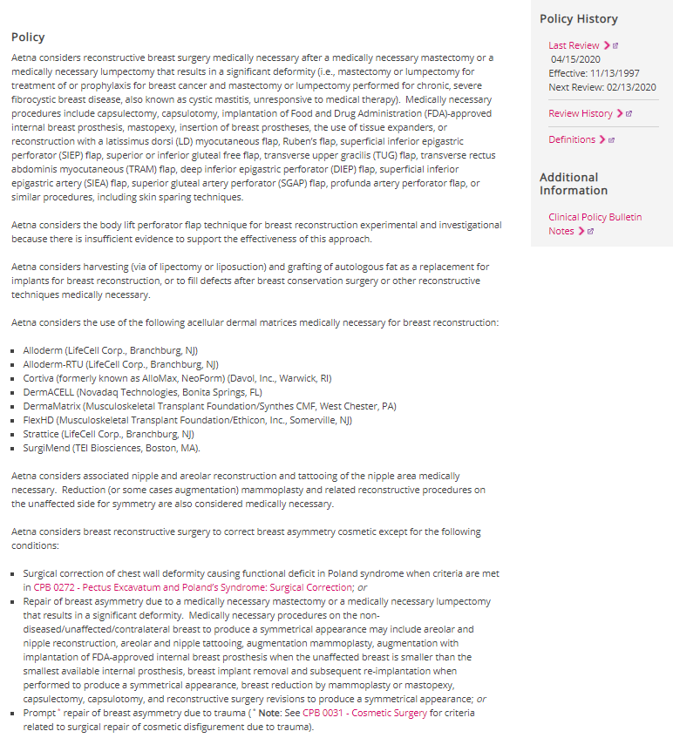
Exhibit D

Source: www.aetna.com/cpb/medical/data/100_199/0185.html#:~:text=Aetna%20considers%20reconstructive%20breast%20surgery,or%20lumpectomy%20performed%20for%20chronic%2C

