HEALTH INSURER
123 Insurance Way
Anywhere, IL 012345
DATE
RE: Claim # XXXXXXXXXXX
Insured: NAME (ID# XXXXXXXXXXX)
Claimant: NAME (DOB Mo-Day-Year)
To Whom It May Concern:
I am writing to appeal the decision to deny coverage of my prophylactic bilateral mastectomy by [Health Plan Name]. Genetic testing confirmed that I carry a mutation in the XXX [insert mutation type as appropriate] gene which puts me at significantly increased risk of breast cancer. With this inherited mutation [and my family history of cancer] my risk of breast cancer is similar to that of a BRCA mutation carrier. The U.S. Preventive Services Task Force (USPSTF) BRCA-Related Cancer: Risk Assessment, Genetic Counseling, and Genetic Testing guidelines give a “Grade: B” to screening women who may be at high risk of breast, ovarian, tubal, or peritoneal cancer. “Women with positive screening results should receive genetic counseling and, if indicated after counseling, BRCA testing.”
The clinical value of identifying people with a genetic mutation placing them at high risk of cancer lies in an individual’s ability to access appropriate, evidence-based screening and preventive services that lower their cancer risk for breast. As such, USPSTF guidelines indicate, “risk-reducing surgery (e.g. mastectomy or salpingo-oophorectomy) is a recommended intervention women at high risk of breast cancer [Exhibit A].
While the USPSTF does not address [my mutation], National Comprehensive Cancer Network (NCCN) guidelines state that risk-reducing mastectomy (RRM) should be an option for women like myself [Exhibit B]. The efficacy of this surgery for reduction of breast cancer risk is unparalleled. The National Cancer Institute says, “Bilateral prophylactic mastectomy has been shown to reduce the risk of breast cancer by at least 95 percent in women who have a deleterious (disease-causing) mutation...and by up to 90 percent in women who have a strong family history of breast cancer.” There is broad consensus among clinical organizations about risk-reducing surgery for women with mutations. The, American Congress of Obstetricians and Gynecologists (ACOG) [Exhibit C], American Cancer Society [Exhibit D], National Cancer Institute [Exhibit E] and others recommend the option of RRM for women with BRCA and other mutations.
Most insurers, including Aetna, consider “prophylactic mastectomy medically necessary for reduction of risk of breast cancer” in high-risk women [Exhibit G]. No woman wants to remove her breasts but given the exceptional risk of cancer, women with these mutations face a difficult choice—live in constant fear with the threat of aggressive and often fatal cancer or opt for surgery to help maintain one’s health.
Given my significant breast cancer risk, this surgery meets the criteria for medical necessity. Thank you for your consideration. With the evidence provided herein, I respectfully request that you allow me to be proactive with my health. Ultimately, the cost of risk-reducing mastectomy with reconstruction is far less expensive than a breast cancer diagnosis—which would involve not only surgery and reconstruction, but chemotherapy, radiation, extensive time out of work, etc. Thank you for your consideration. Your prompt attention to this appeal is greatly appreciated.
Sincerely,
[Signature]
Exhibit A

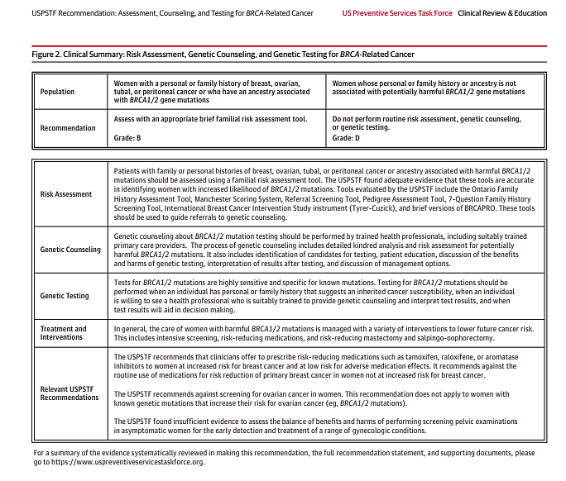
Source: https://jamanetwork.com/journals/jama/fullarticle/2748515?appid=scweb&alert=article

Exhibit B

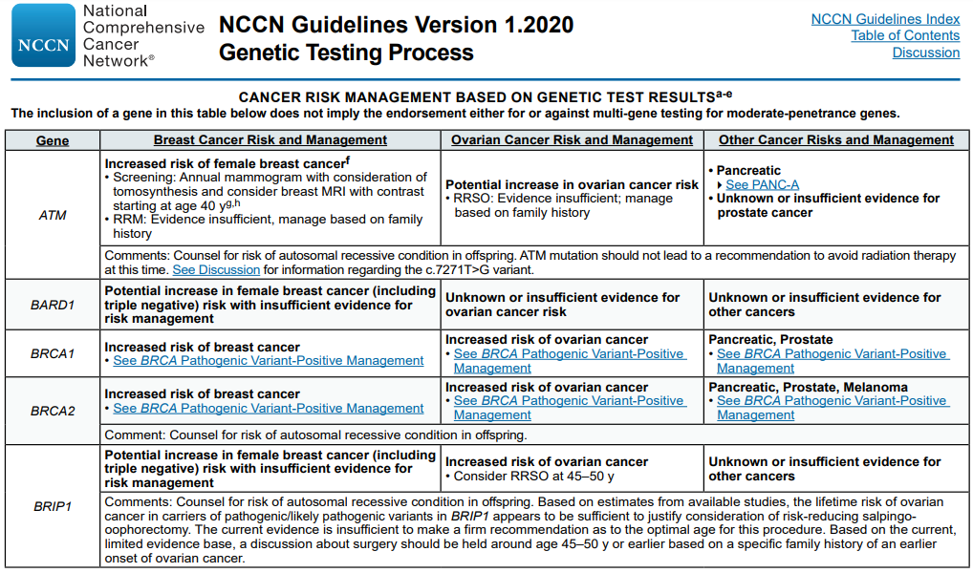
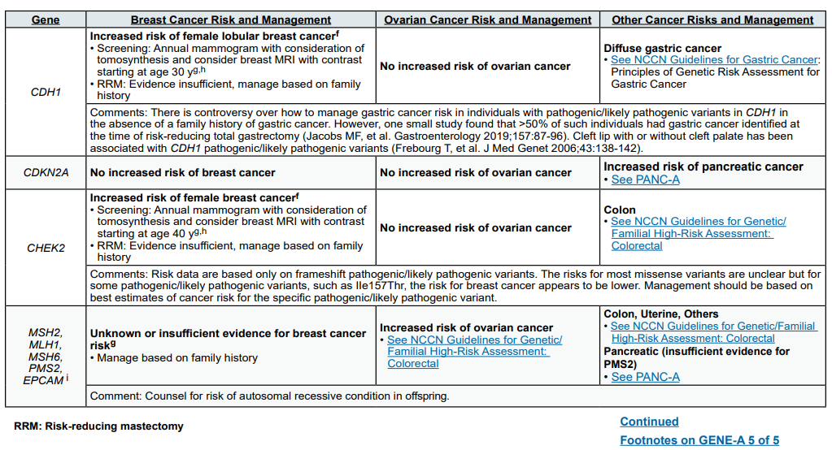
Source: www.nccn.org/professionals/physician_gls/pdf/genetics_bop.pdf

Exhibit B (continued)

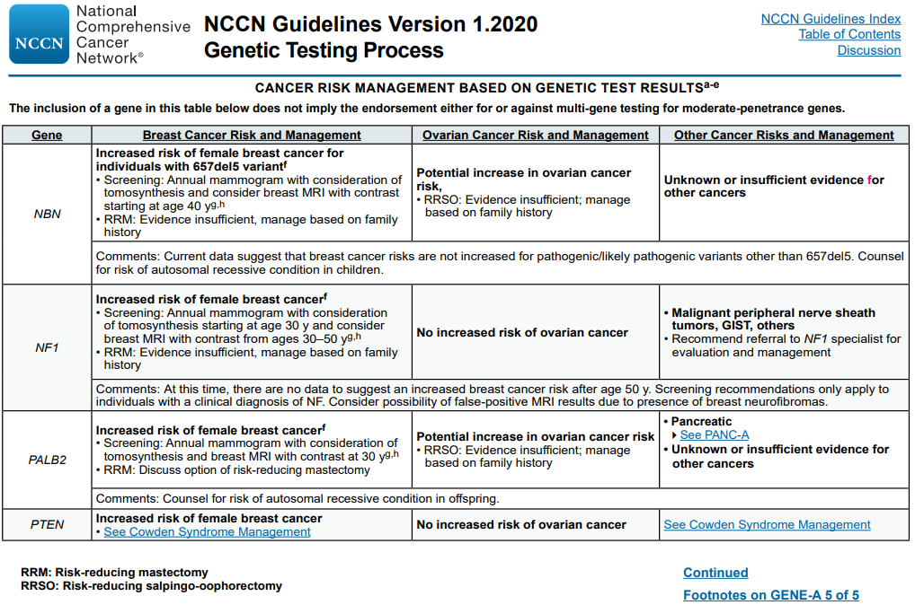
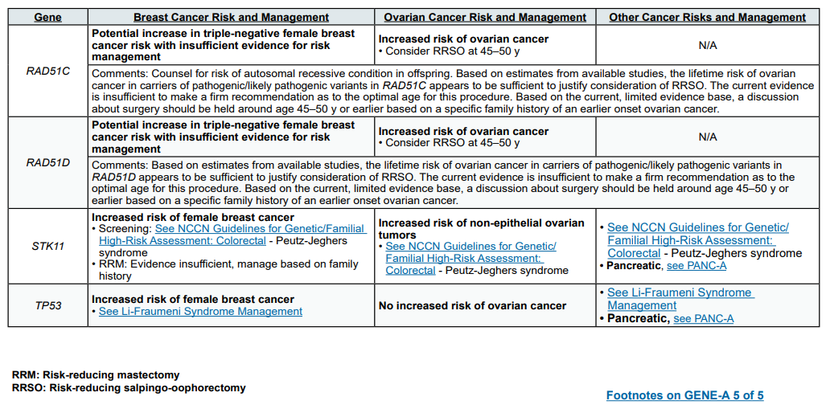
Source: www.nccn.org/professionals/physician_gls/pdf/genetics_bop.pdf

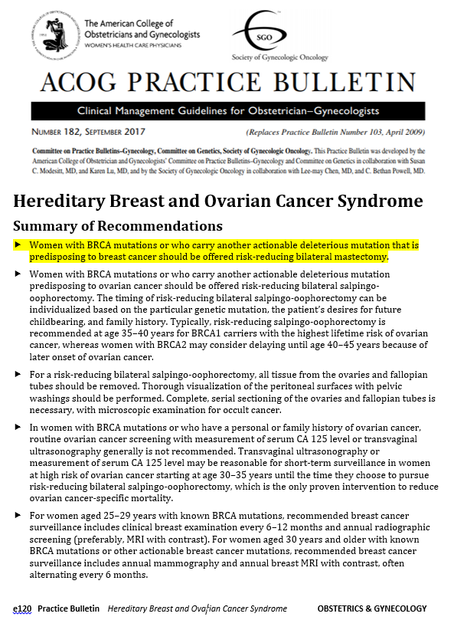
Exhibit C

Source: www.sgo.org/wp-content/uploads/2012/09/PB-182.pdf

Exhibit D

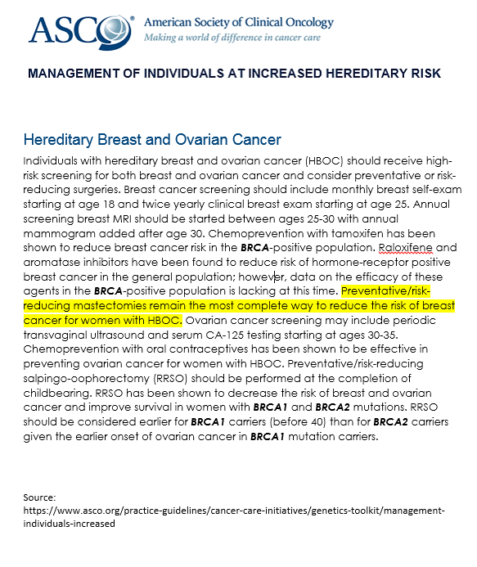
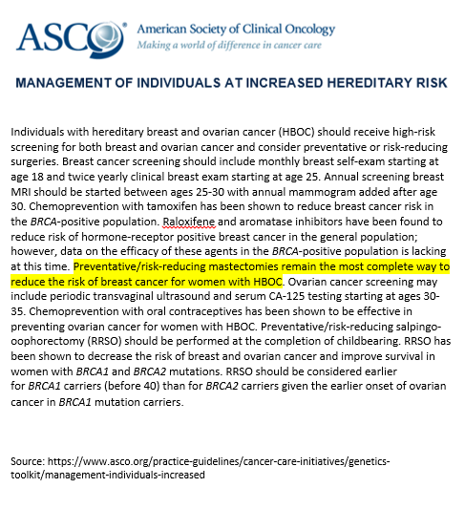

Exhibit E
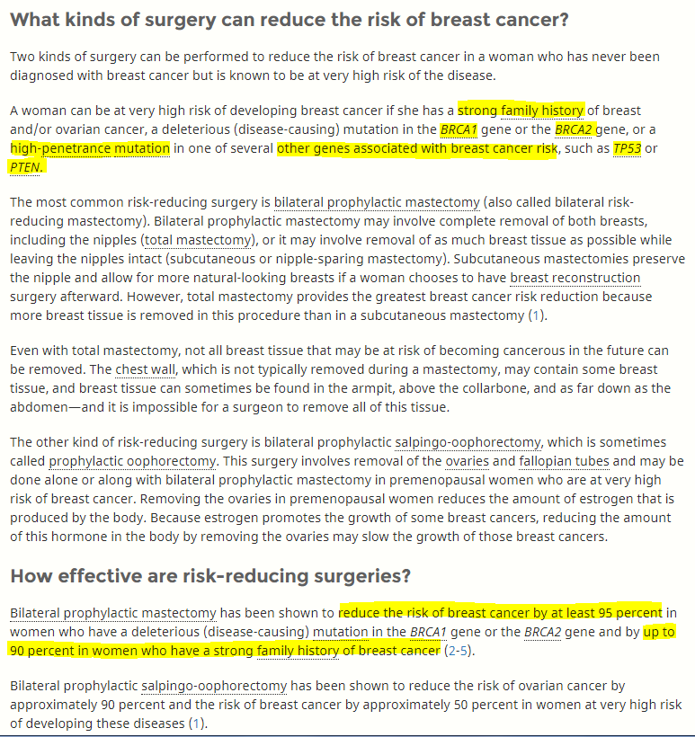

Source: https://www.cancer.gov/types/breast/risk-reducing-surgery-fact-sheet#q9

Exhibit G
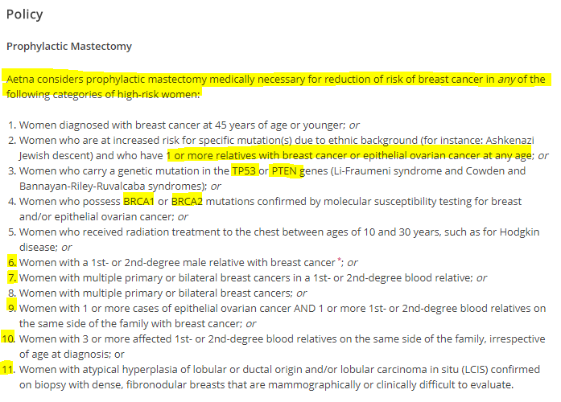

Source: http://www.aetna.com/cpb/medical/data/200_299/0227.html

BRCA-Related Cancer: Risk Assessment, Genetic Counseling, and Genetic Testing (www.uspreventiveservicestaskforce.org/uspstf/recommendation/brca-related-cancer-risk-assessment-genetic-counseling-and-genetic-testing)
Surgery to Reduce the Risk of Breast Cancer (www.cancer.gov/types/breast/risk-reducing-surgery-fact-sheet)

