HEALTH INSURER
123 Insurance Way
Anywhere, IL 012345
DATE
RE: Claim # XXXXXXXXXXX
Insured: NAME (ID# XXXXXXXXXXX)
Claimant: NAME (DOB Mo-Day-Year)

To Whom It May Concern:
I am writing to appeal the decision to deny coverage of my prophylactic bilateral mastectomy by [Health Plan Name]. Genetic testing confirmed that I carry a BRCA genetic mutation which puts me at significantly increased risk of breast and ovarian cancer. The U.S. Preventive Services Task Force (USPSTF) BRCA-Related Cancer: Risk Assessment, Genetic Counseling, and Genetic Testing guidelines give a “Grade: B” to screening women who may be at high risk of breast, ovarian, tubal, or peritoneal cancer. “Women with positive screening results should receive genetic counseling and, if indicated after counseling, BRCA testing.”
The clinical value of identifying people with a BRCA mutation lies in an individual’s ability to access appropriate, evidence-based screening and preventive services that lower the risk for breast or ovarian cancer. As such, USPSTF guidelines indicate, “risk-reducing surgery (e.g. mastectomy or salpingo-oophorectomy) is a recommended intervention for “women who are BRCA mutation carriers.” [Exhibits A and B]
The National Cancer Institute says, “Bilateral prophylactic mastectomy has been shown to reduce the risk of breast cancer by at least 95 percent in women who have a deleterious (disease-causing) mutation in the BRCA1 gene or the BRCA2 gene.” There is broad consensus among clinical organizations about the benefits of risk-reducing surgery in women with BRCA mutations. The National Comprehensive Cancer Network (NCCN) [Exhibit C], American Congress of Obstetricians and Gynecologists (ACOG) [Exhibit D], American Society of Clinical Oncology (ASCO) [Exhibit E], National Cancer Institute [Exhibit F] and others recommend bilateral prophylactic mastectomy, also known as a risk-reducing mastectomy (RRM), for women with BRCA mutations.
Most insurers, including Blue Cross and Aetna plans, consider “prophylactic mastectomy medically necessary for reduction of risk of breast cancer” in high-risk “women who possess BRCA1 or BRCA2 mutations” [Exhibit G and H]. No woman wants to remove her breasts but given the exceptionally high risk of cancer (up to 87% lifetime risk), women with these mutations are faced with a difficult choice—live in constant fear with the threat of aggressive and often fatal cancer or opt for surgery to help maintain one’s health.
In summary, this surgery is medically necessary. Exclusion of risk-reducing procedures for high-risk women does not align with national medical guidelines and the current standard of care. Thank you for your consideration. Your prompt attention to this appeal is greatly appreciated.
Sincerely,
[Signature]
Exhibit A
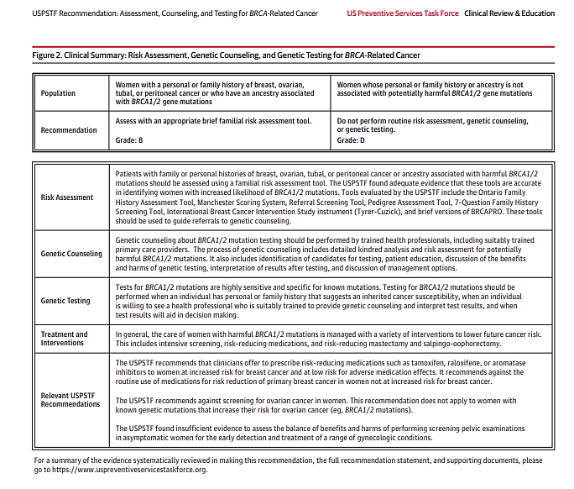

Source: https://jamanetwork.com/journals/jama/fullarticle/2748515?appid=scweb&alert=article

Exhibit B
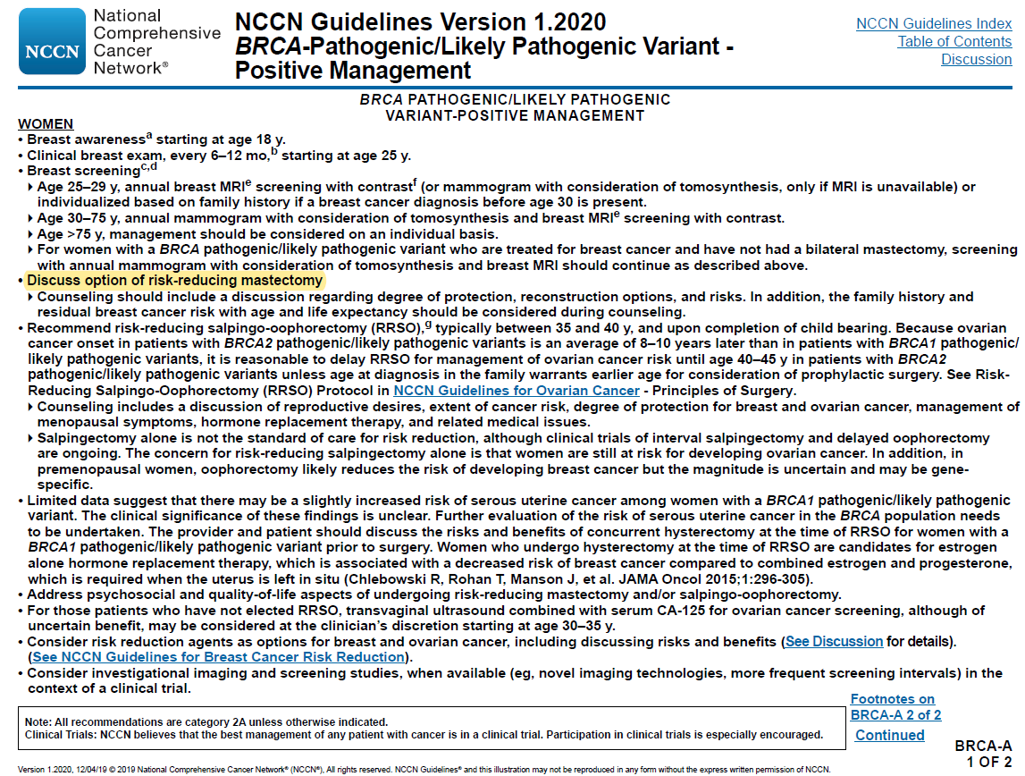
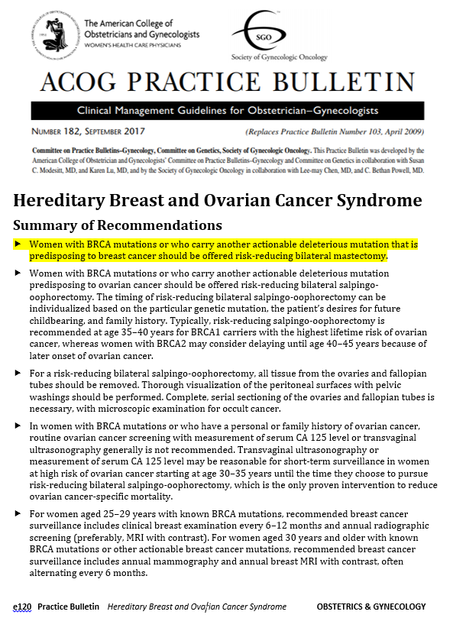
Exhibit C
Source: www.sgo.org/wp-content/uploads/2012/09/PB-182.pdf

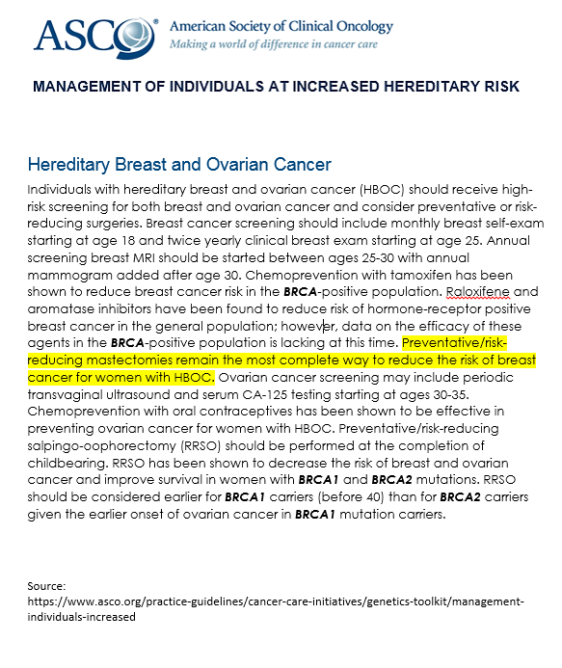
Exhibit D

Exhibit F
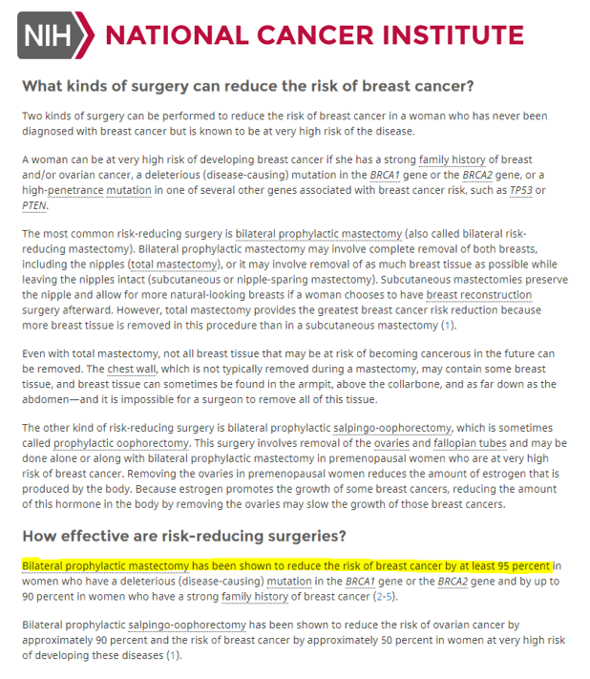

Source: www.cancer.gov/types/breast/risk-reducing-surgery-fact-sheet#q9

Exhibit G

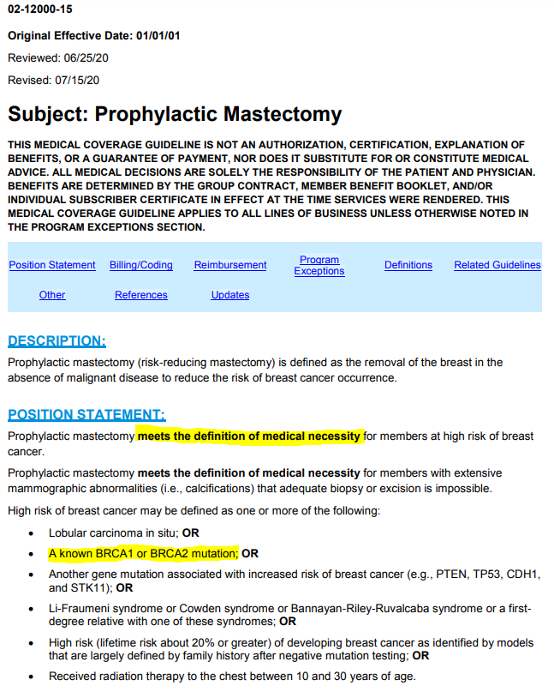
Source: http://mcgs.bcbsfl.com/MCG?mcgId=02-12000-15&pv=false

Exhibit H
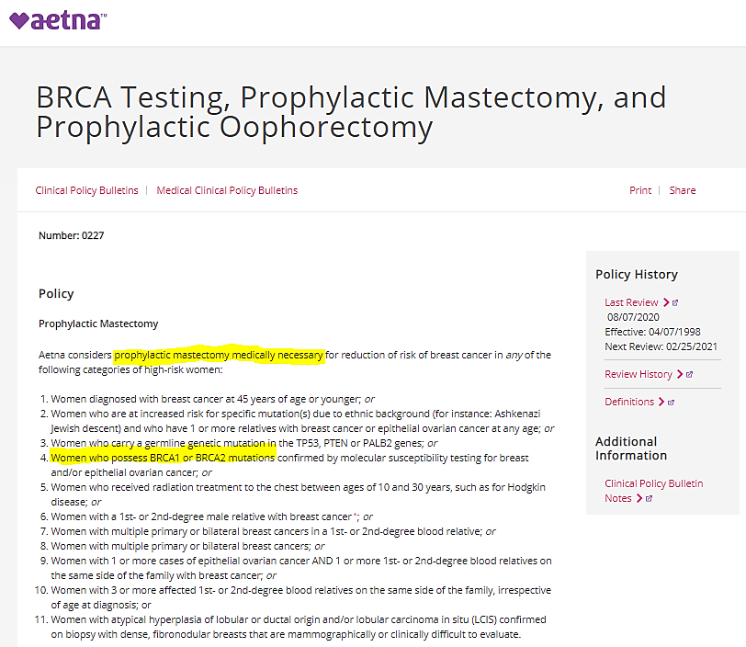

Source: www.aetna.com/cpb/medical/data/200_299/0227.html

BRCA-Related Cancer: Risk Assessment, Genetic Counseling, and Genetic Testing, December 2019 (https://www.uspreventiveservicestaskforce.org/Page/Document/RecommendationStatementFinal/brca-related-cancer-risk-assessment-genetic-counseling-and-genetic-testing1)
Surgery to Reduce the Risk of Breast Cancer (www.cancer.gov/types/breast/risk-reducing-surgery-fact-sheet)

