HEALTH INSURER
123 Insurance Way
Anywhere, IL 012345
DATE
RE: Claim # XXXXXXXXXXX
Insured: NAME (ID# XXXXXXXXXXX)
Claimant: NAME (DOB Mo-Day-Year)

To Whom It May Concern:
I am writing to appeal the decision to deny coverage of a [breast reduction and lift] in conjunction with my prophylactic bilateral mastectomy and reconstruction. Genetic testing confirmed that I carry an inherited genetic mutation that puts me at significantly increased risk of breast cancer. The U.S. Preventive Services Task Force (USPSTF) Risk Assessment, Genetic Counseling, and Genetic Testing guidelines give a “Grade: B” to screening women who may be at high risk of breast, ovarian, tubal, or peritoneal cancer. “Women with positive screening results should receive genetic counseling and, if indicated after counseling, BRCA testing.” A number of other mutations conveying similar risk of breast cancer have been identified.
The clinical value of identifying people with a high risk of cancer lies in an individual’s ability to access appropriate, evidence-based screening and preventive services that lower that risk. As such, USPSTF guidelines indicate, “risk-reducing surgery (e.g. mastectomy or salpingo-oophorectomy) is a recommended intervention for “women who are BRCA mutation carriers” [Exhibit A] and state the benefits of risk-reducing surgery [Exhibit B].
The National Cancer Institute says, “Bilateral prophylactic mastectomy has been shown to reduce the risk of breast cancer by at least 95 percent in women who have a deleterious (disease-causing) mutation in the BRCA1 gene or the BRCA2 gene and by up to 90 percent in women with a strong family history of breast cancer.” There is broad consensus among clinical organizations about the benefits of risk-reducing surgery in women with genetic mutations or other high-risk factors. The National Comprehensive Cancer Network (NCCN) [Exhibit C], American Congress of Obstetricians and Gynecologists (ACOG) [Exhibit D], American Society of Clinical Oncology (ASCO) [Exhibit E], National Cancer Institute [Exhibit F] and others recommend bilateral prophylactic mastectomy, also known as a risk-reducing mastectomy (RRM), for women with a high risk of breast cancer.
The Women’s Health and Cancer Rights Act (WHCRA) requires most individual and group health plans to pay for breast reconstruction in conjunction with mastectomy. The Department of Labor specifies, “…nothing in the law limits WHCRA rights to cancer patients.” In other words, any woman undergoing a mastectomy deemed to be medically necessary is entitled to “all stages of reconstruction of the breast on which the mastectomy was performed, surgery and reconstruction of the other breast to produce a symmetrical appearance, prostheses and treatment of physical complications of the mastectomy, including lymphedema.” [Exhibits G and H]

Every woman’s body is unique so the reconstruction process is not “one size fits all.” To accommodate these differences, most health insurers cover various types and phases of breast reconstruction associated with a mastectomy [Exhibits I and J]. No one wants to undergo a mastectomy but a satisfactory outcome is not too much to ask.
Reduction mammoplasty and mastopexy before or following a risk-reducing mastectomy and reconstruction have become the standard-of-care for certain patients over the past decade. Numerous studies confirm its safety, efficacy and successful outcomes in women with breast ptosis.,,
Mastectomy-related breast reconstruction can significantly affect an individual’s body image, self-esteem, and quality of life. WHRCA exists to help ensure that women have a choice and some sense of control when faced with a mastectomy, allowing them to work with their healthcare providers to choose the type of reconstruction best suited for them.
My surgeons have determined that reduction mammoplasty and mastopexy are medically necessary to achieve optimal reconstructive results. Without these procedures, I am more likely to experience complications, which will ultimately result in higher costs for my reconstruction. It is much more logical and cost-effective to trust my providers in their conclusion that this is a crucial step in my reconstruction given my breast size and shape.
In summary, a breast reduction and lift are a medically necessary stage in my mastectomy and reconstruction. I respectfully request that [insurer name] cover this surgery. Thank you for your consideration. Your prompt attention to this appeal is greatly appreciated.
Sincerely,
[Signature]

Exhibit A
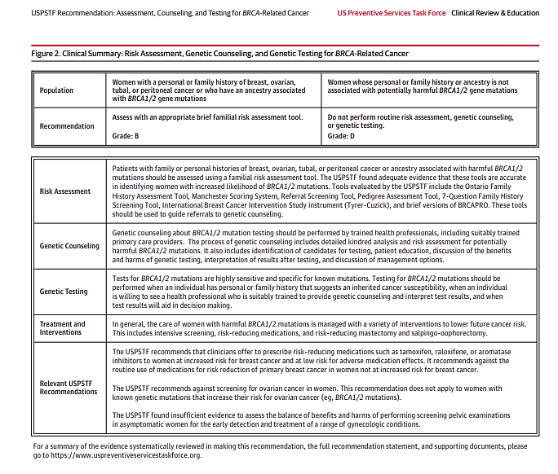

Source: Figure2 - https://jamanetwork.com/journals/jama/fullarticle/2748515?appid=scweb&alert=article
Exhibit B
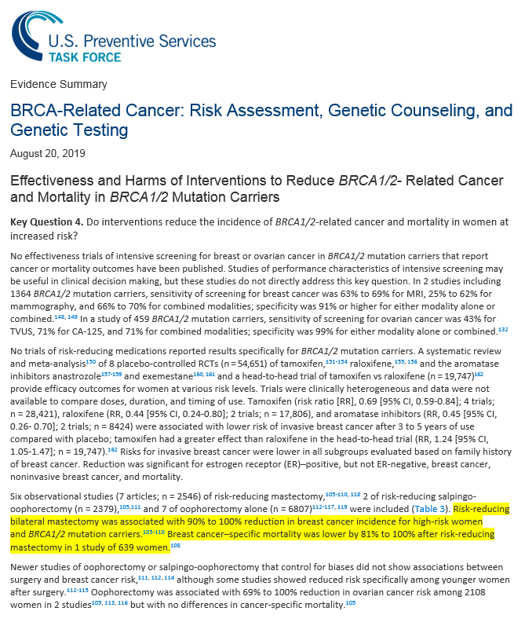
Source: www.uspreventiveservicestaskforce.org/uspstf/document/evidence-summary/brca-related-cancer-risk-assessment-genetic-counseling-and-genetic-testing

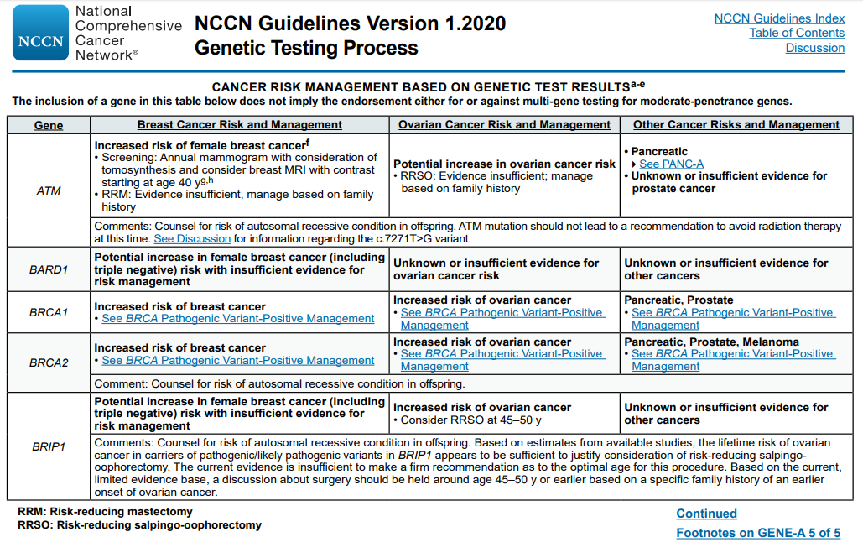
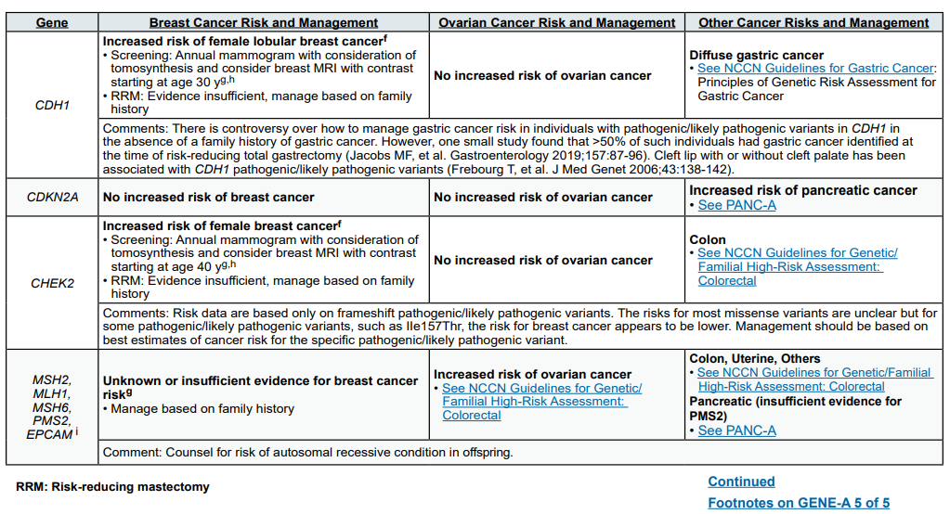
Exhibit C
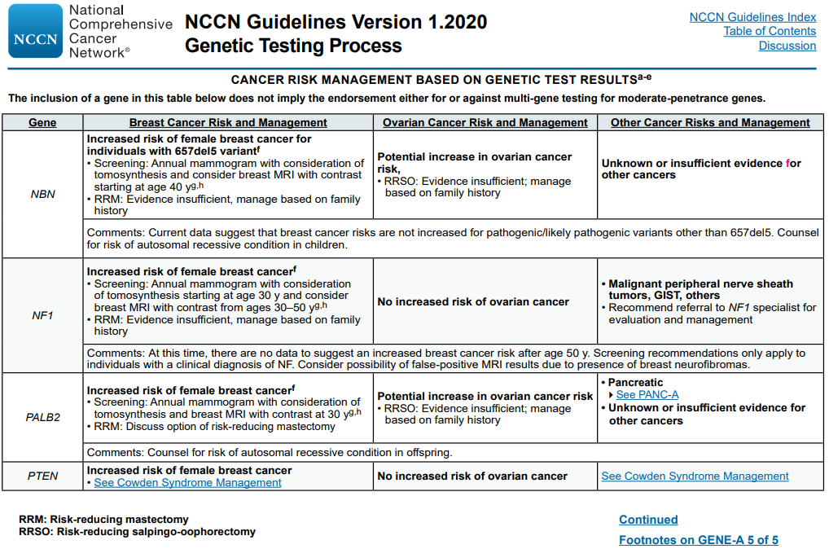
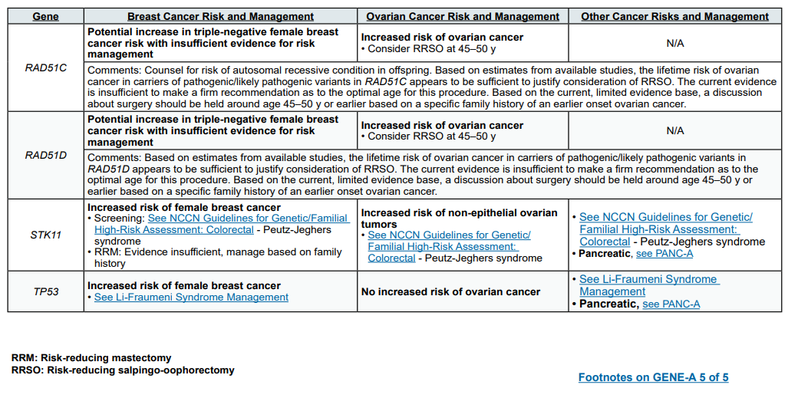
Exhibit C (continued)
Source: www.nccn.org/professionals/physician_gls/pdf/genetics_bop.pdf

Exhibit D
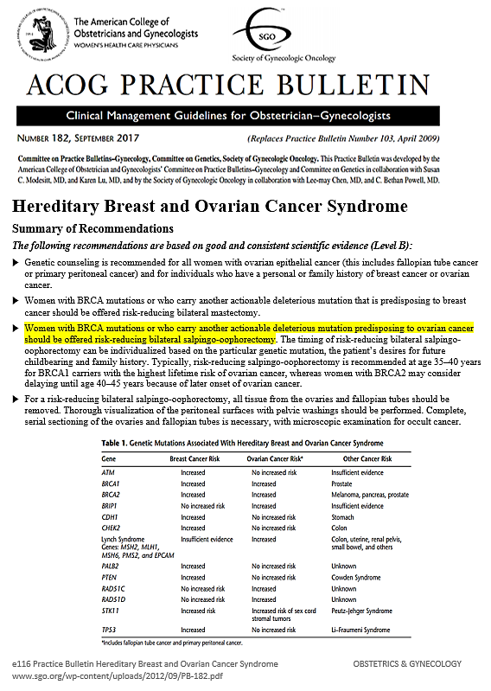
Exhibit E

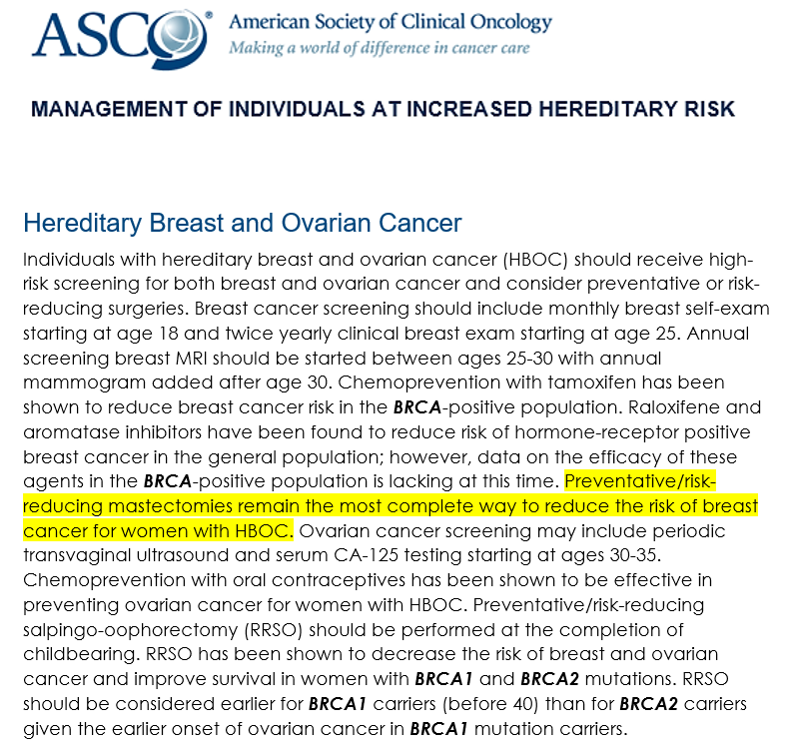
Source:
www.asco.org/practice-guidelines/cancer-care-initiatives/genetics-toolkit/management-individuals-increased

Exhibit F
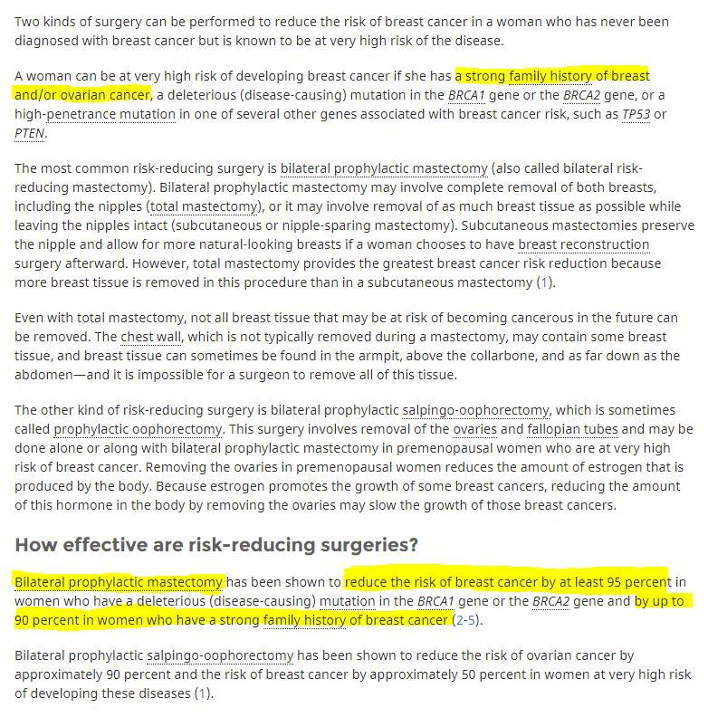
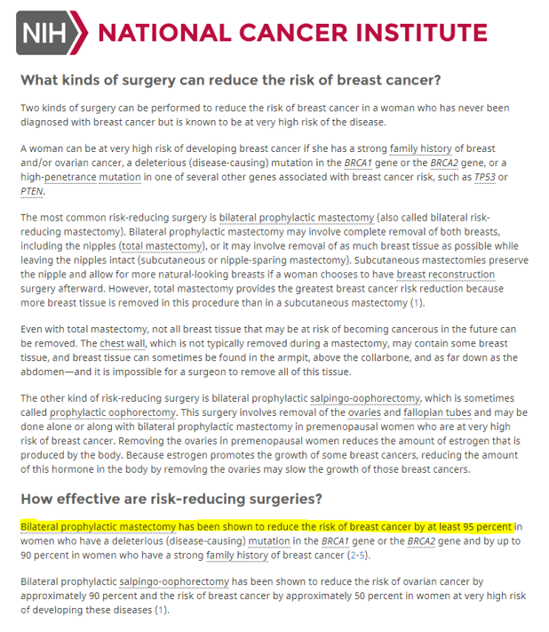

Source: www.cancer.gov/types/breast/risk-reducing-surgery-fact-sheet#q9

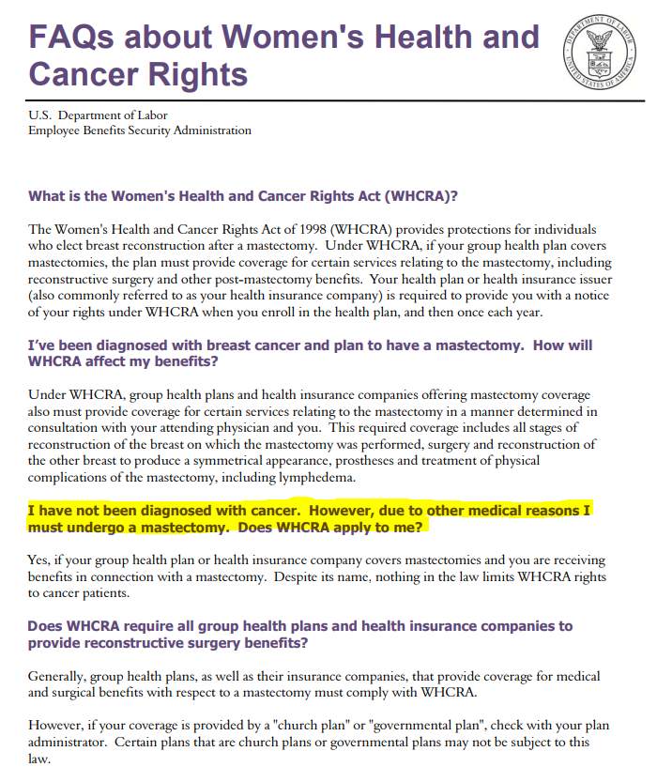
Exhibit G

Source: www.dol.gov/sites/default/files/ebsa/about-ebsa/our-activities/resource-center/faqs/whcra.pdf

Exhibit H

Women's Health and Cancer Rights Act (WHCRA)
The Women's Health and Cancer Rights Act of 1998 (WHCRA) is a federal law that provides protections to patients who choose to have breast reconstruction in connection with a mastectomy.
If WHCRA applies to you and you are receiving benefits in connection with a mastectomy and you elect breast reconstruction, coverage must be provided for:
- All stages of reconstruction of the breast on which the mastectomy has been performed;
- Surgery and reconstruction of the other breast to produce a symmetrical appearance; and
- Prostheses and treatment of physical complications of all stages of the mastectomy, including lymphedema.
This law applies to two different types of coverage:
- Group health plans (provided by an employer or union);
- Individual health insurance policies (not based on employment).
Group health plans can either be “insured” plans that purchase health insurance from a health insurance issuer, or “self-funded” plans that pay for coverage directly. How they are regulated depends on whether they are sponsored by private employers, or state or local (“non-federal”) governmental employers. Private group health plans are regulated by the Department of Labor. State and local governmental plans, for purposes of WHCRA, are regulated by CMS. If any group health plan buys insurance, the insurance itself is regulated by the State’s insurance department.
Contact your employer’s plan administrator to find out if your group coverage is insured or self-funded, to determine what entity or entities regulate your benefits.
Health insurance sold to individuals (not through employment) is primarily regulated by State insurance departments.
WHCRA requires group health plans and health insurance companies (including HMOs), to notify individuals regarding coverage required under the law. Notice about the availability of these mastectomy-related benefits must be given:
- To participants and beneficiaries of a group health plan at the time of enrollment, and to policyholders at the time an individual health insurance policy is issued; and
- Annually to group health plan participants and beneficiaries, and to policyholders of individual policies.
Contact your State's insurance department to find out whether additional state law protections apply to your coverage if you are in an insured group health plan or have individual (non-employment based) health insurance coverage.
WHCRA does not apply to high risk pools since the pool is a means by which individuals obtain health coverage other than through health insurance policies or group health plans.
WHCRA does NOT require group health plans or health insurance issuers to cover mastectomies in general. If a group health plan or health insurance issuer chooses to cover mastectomies, then the plan or issuer is generally subject to WHCRA requirements.
Note: A non-Federal governmental employer that provides self-funded group health plan coverage to its employees (coverage that is not provided through an insurer) may elect to exempt its plan (opt out) from the requirements of WHCRA by following the “Procedures & Requirements for HIPAA Exemption Election” posted on the Self-Funded Non-Federal Governmental Plans webpage at http://cms.gov/cciio/resources/files/hipaa_exemption_election_instructions_04072011.html. This includes a requirement to issue a notice of opt-out to enrollees at the time of enrollment and on an annual basis. For a list of plans that have opted out of WHCRA, go to http://cms.gov/cciio/resources/other/index.html#nonfed and click on “List of HIPAA Opt-out Elections for Self-funded Non-Federal Governmental Plans.”
If you have concerns about your plan’s compliance with WHCRA, contact our help line at 1-877-267-2323 extension 6-1565 or at phig@cms.hhs.gov.
Source: www.cms.gov/CCIIO/Programs-and-Initiatives/Other-Insurance-Protections/whcra_factsheet.html

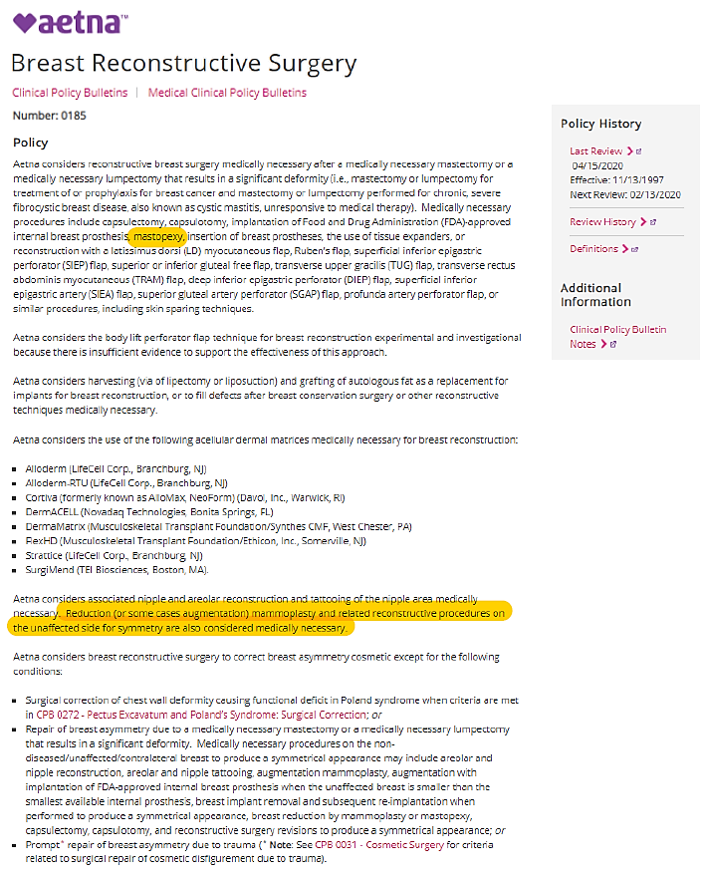
Source: www.aetna.com/cpb/medical/data/100_199/0185.html#:~:text=Aetna%20considers%20reconstructive%20breast%20surgery,or%20lumpectomy%20performed%20for%20chronic%2C

Exhibit I
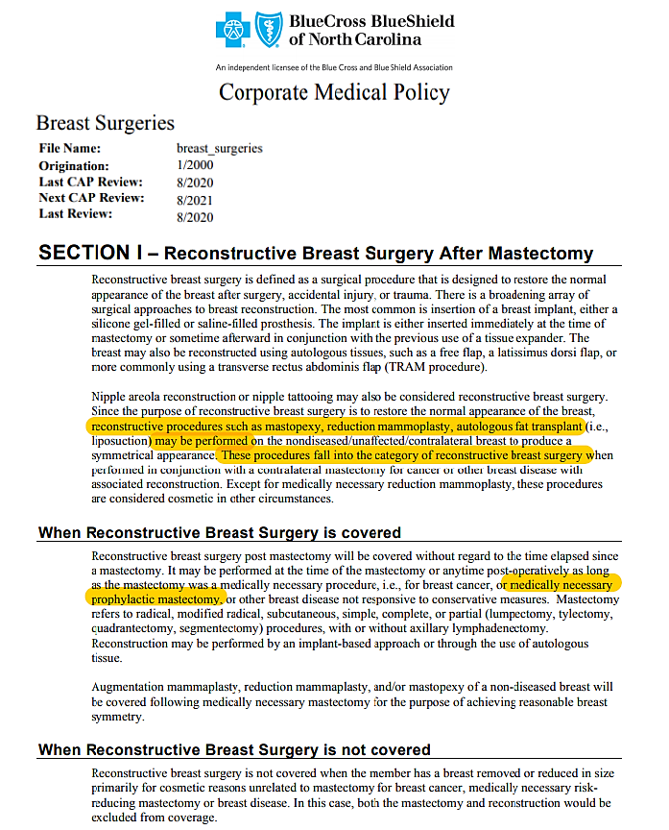

Source: www.bluecrossnc.com/sites/default/files/document/attachment/services/public/pdfs/medicalpolicy/breast_surgeries.pdf

Surgery to Reduce the Risk of Breast Cancer (www.cancer.gov/types/breast/risk-reducing-surgery-fact-sheet)
Prophylactic Nipple-Sparing Mastectomy and Direct-to-Implant Reconstruction of the Large and Ptotic Breast: Is Preshaping of the Challenging Breast a Key to Success? Gunnarsson GL, Bille C, Reitsma LC, et al. Plastic and Reconstructive Surgery: September 2017 - Volume 140 - Issue 3 - p 449–454.
Breast Reconstruction Using a Staged Nipple-Sparing Mastectomy following Mastopexy or Reduction. Spear S, Rottman S, Hannan CM, Seiboth LA. Plastic and Reconstructive Surgery. March 2012, 129(3):572-81.
Prophylactic Bilateral Nipple-sparing Mastectomy and a Staged Breast Reconstruction Technique: Preliminary Results. Tondu T, Tiessen F, Weibren T. Breast Cancer. 2016; 10: 185–189.

