HEALTH INSURER
123 Insurance Way
Anywhere, IL 012345
DATE
RE: Claim # XXXXXXXXXXX
Insured: NAME (ID# XXXXXXXXXXX)
Claimant: NAME (DOB Mo-Day-Year)

To Whom It May Concern:
I am writing to appeal [Health Plan Name]’s decision to deny coverage of my breast screening MRI, which took place on [date] at [radiology facility]. It is my understanding that [Health Plan Name] covers medically necessary services that are not expressly excluded. [Attach or reference relevant section(s) from health insurer’s Policy or Evidence of Coverage, if possible.]
I recognize that breast MRI is not a covered benefit for women considered to be at low- or average- risk of developing breast cancer. However, genetic testing confirmed that I carry a BRCA mutation which places me at high risk for breast cancer. The clinical value of identifying people at increased risk of cancer lies in an individual’s ability to access appropriate, evidence-based screening and preventive services that identify cancer at earlier stages or lower the risk of cancer.
My healthcare team has indicated that an annual breast MRI is medically necessary for risk management. There is broad consensus about the medical necessity of breast screening MRI for women at high risk of breast cancer. The National Comprehensive Cancer Network (NCCN) is a professional organization that develops standard-of-care consensus guidelines in cancer. Its Practice Guidelines for “Genetic/Familial High-Risk Assessment: Breast, Ovarian, and Pancreatic” state that women with a BRCA mutation should begin annual breast screening MRIs at age 25 (or younger if family history of breast cancer before age 30 is present). [Exhibit A]
The American Congress of Obstetricians and Gynecologists (ACOG) [Exhibit B], American Cancer Society [Exhibit C], and American College for Radiology (ACR) and Society of Breast Imaging [Exhibit D] also recommend annual breast MRI for high-risk women and BRCA mutation carriers.
Given this evidence of medical necessity, I respectfully request that you reverse the denial of this claim. Additionally, I would like it noted for the future that my annual breast screening MRI is a covered benefit given my high risk of breast cancer. The guidelines make it clear that this service is a necessary intervention for high-risk women such as myself.
Thank you for your consideration. Your prompt attention to this appeal is greatly appreciated.
Sincerely,
[Signature]
Exhibit A
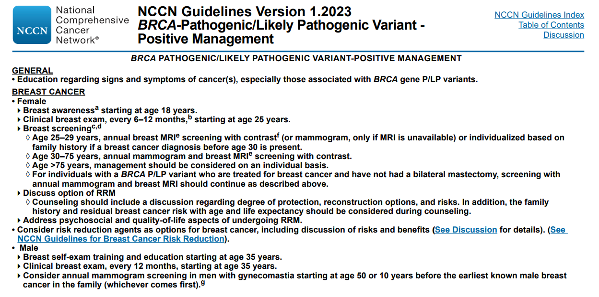
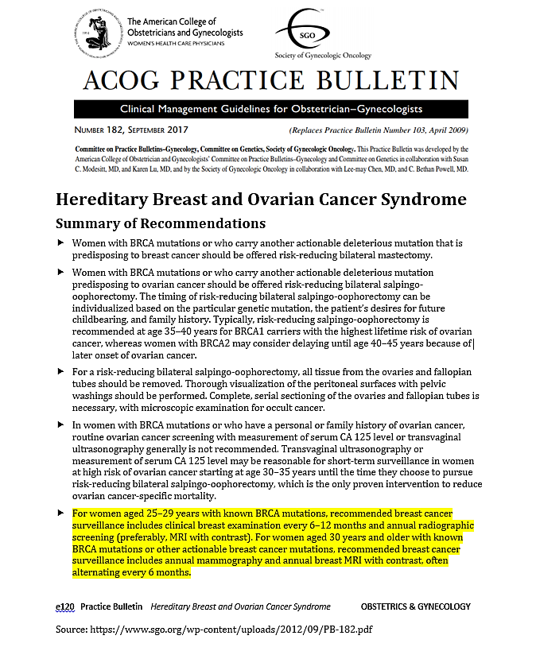
Exhibit B
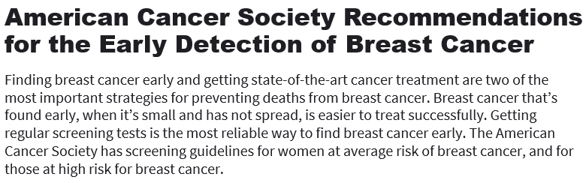
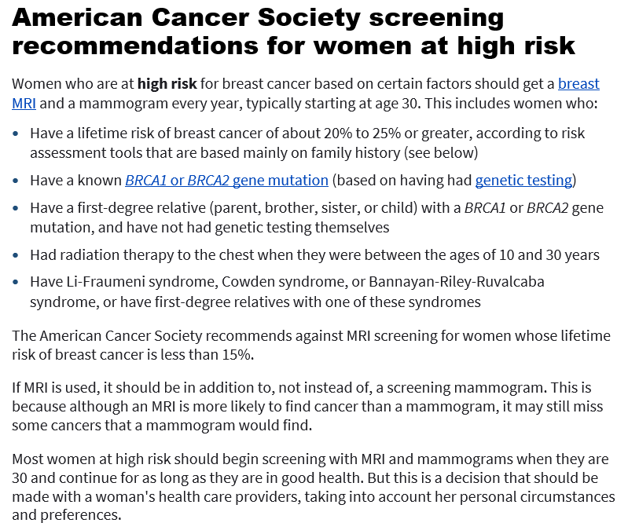
Exhibit C

Last Revised: January 14, 2022
Source:
www.cancer.org/cancer/breast-cancer/screening-tests-and-early-detection/american-cancer-society-recommendations-for-the-early-detection-of-breast-cancer.html
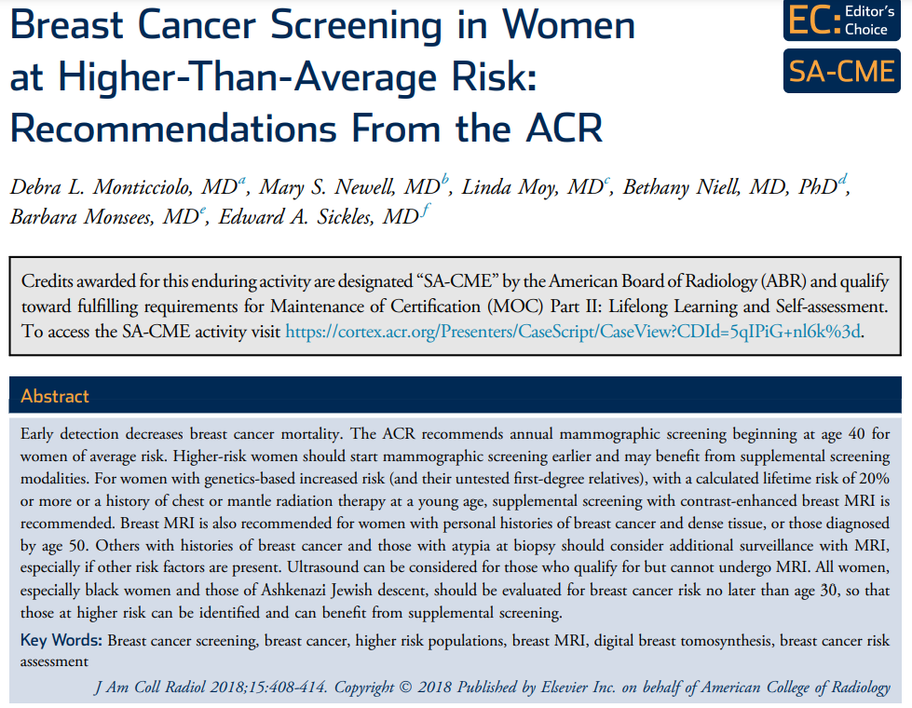
Exhibit D
TAKE-HOME POINTS
- For women with genetics-based increased risk (and their untested first-degree relatives) or with a calculated lifetime risk of 20% or more, DM, with or without DBT, should be performed annually beginning at age 30.
- For women with histories of chest radiation therapy before the age of 30, DM, with or without DBT, should be performed annually beginning at age 25 or 8 years after radiation therapy, whichever is later.
- For women with genetics-based increased risk (and their untested first-degree relatives), histories of chest radiation (cumulative dose of $≥$10 Gy before age 30), or a calculated lifetime risk of 20% or more, breast MRI should be performed annually beginning at age 25 to 30.
- For women with personal histories of breast cancer and dense breast tissue, or those diagnosed before age 50, annual surveillance with breast MRI is recommended.
- For women with personal histories not included in the above, or with ADH, atypical lobular hyperplasia, or LCIS, MRI should be considered, especially if other risk factors are present.
- All women, especially black women and those of Ashkenazi Jewish descent, should be evaluated for breast cancer risk no later than age 30, so that those at higher risk can be identified and can benefit from supplemental screening.

Source:
www.jacr.org/action/showPdf?pii=S1546-1440%2817%2931524-7

NCCN Clinical Practice Guidelines in Oncology: Genetic/Familial High-Risk Assessment: Breast, Ovarian, and Pancreatic, Version 1.2023 — September 7, 2022 (www.nccn.org/professionals/physician_gls/pdf/genetics_bop.pdf)

