HEALTH INSURER
123 Insurance Way
Anywhere, IL 012345
DATE
RE: Claim # XXXXXXXXXXX
Insured: NAME (ID# XXXXXXXXXXX)
Claimant: NAME (DOB Mo-Day-Year)
To Whom It May Concern:
I am writing to appeal the decision to deny coverage of my bilateral-salpingo-oophorectomy by [Health Plan Name]. Genetic testing confirmed that I carry a XXXXXX genetic mutation, which puts me at significantly increased risk of ovarian cancer. The U.S. Preventive Services Task Force (USPSTF) Risk Assessment, Genetic Counseling, and Genetic Testing guidelines give a “Grade: B” to screening women who may be at high risk of breast, ovarian, tubal, or peritoneal cancer. “Women with positive screening results should receive genetic counseling and, if indicated after counseling, BRCA testing.” A number of other inherited mutations conveying similar risk of ovarian cancer have been identified.
The clinical value of identifying people with an inherited mutation associated with increased risk of cancer lies in an individual’s ability to access appropriate, evidence-based screening and preventive services that lower the risk for cancer. As such, USPSTF guidelines indicate that “risk-reducing salpingo-oophorectomy” is a recommended intervention [Exhibit A].
The National Cancer Institute indicates, “Bilateral prophylactic salpingo-oophorectomy has been shown to reduce the risk of ovarian cancer by approximately 90 percent and the risk of breast cancer by approximately 50 percent in women at very high risk of developing these diseases.” There is broad consensus among clinical organizations about the benefits of risk-reducing surgery in women with BRCA mutations. The National Comprehensive Cancer Network (NCCN) [Exhibit B], American Congress of Obstetricians and Gynecologists (ACOG) [Exhibit C], and American Society of Clinical Oncology (ASCO) [Exhibit D] all recognize that preventive risk-reducing bilateral salpingo-oophorectomy is necessary for women with a genetic mutation such as mine.
Unfortunately, there is no reliable screening or early detection for ovarian cancer. The FDA confirmed this in its “Ovarian Cancer Screening tests: Safety Communication – FDA Recommends Against Use.” Most health insurers, including Aetna and Blue Cross, consider risk-reducing bilateral salpingo-oophorectomy medically necessary in high-risk women [Exhibits E and F]. Surgery is not something to be taken lightly, but given my high risk of cancer and the evidence of medical necessity, my medical team and I determined that it [was/is] a needed intervention. I respectfully request that you reverse the denial of coverage for this surgery.
Thank you for your consideration. Your prompt attention to this appeal is greatly appreciated.
Sincerely,
[Signature]
Exhibit A
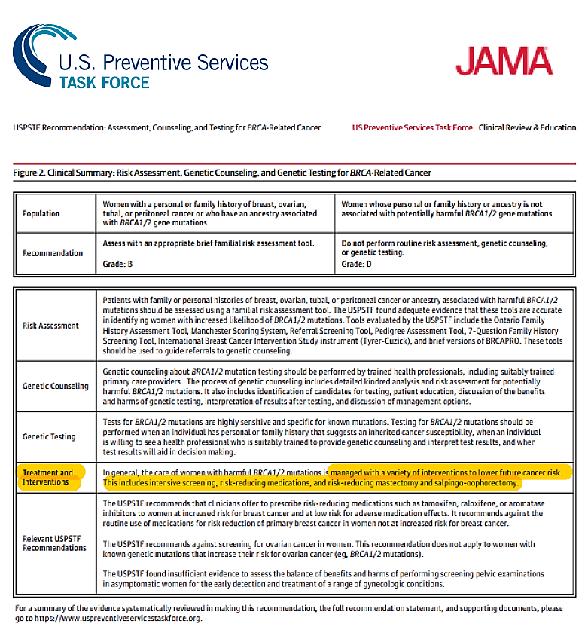
Source: Figure 2 - https://jamanetwork.com/journals/jama/fullarticle/2748515?appid=scweb&alert=article
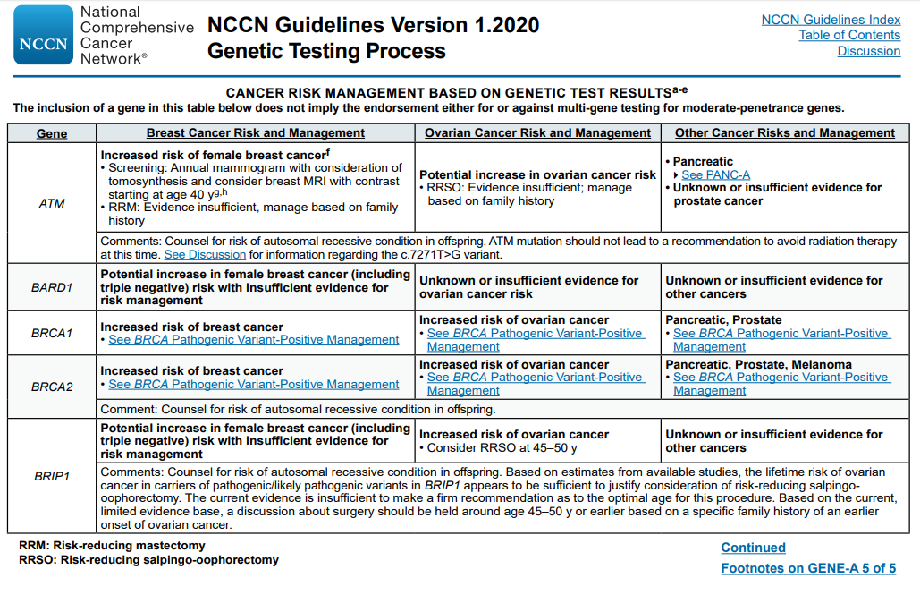
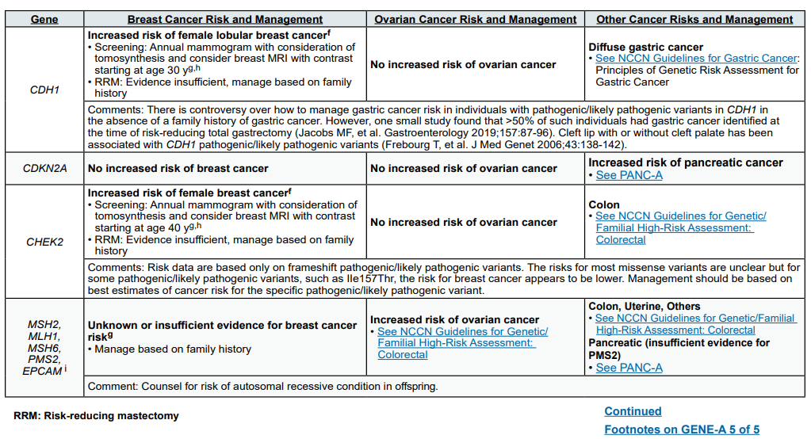
Exhibit B

Exhibit B (continued)
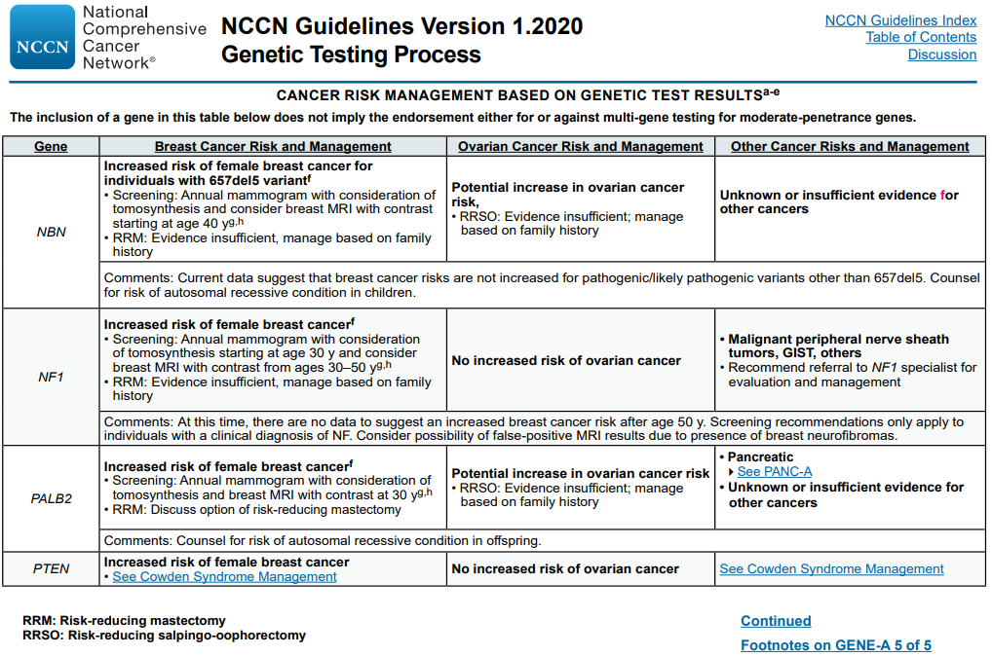
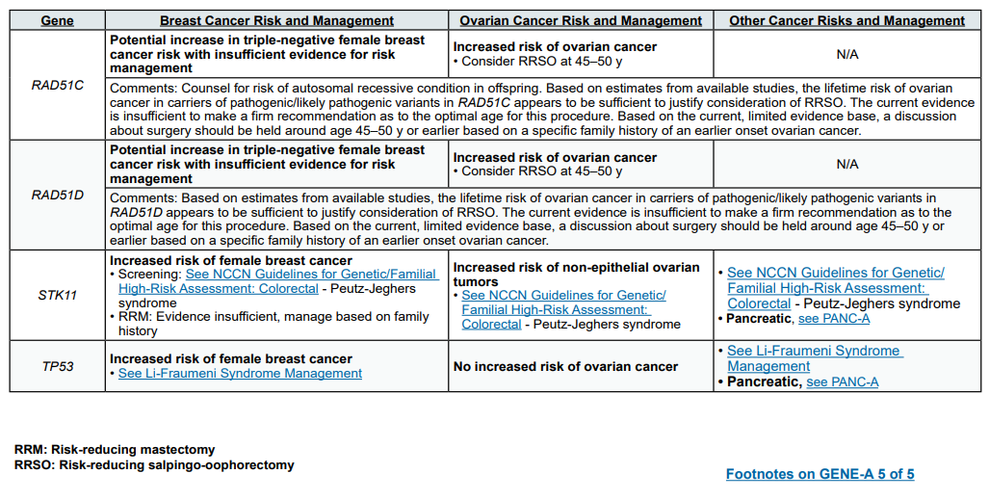
Exhibit C
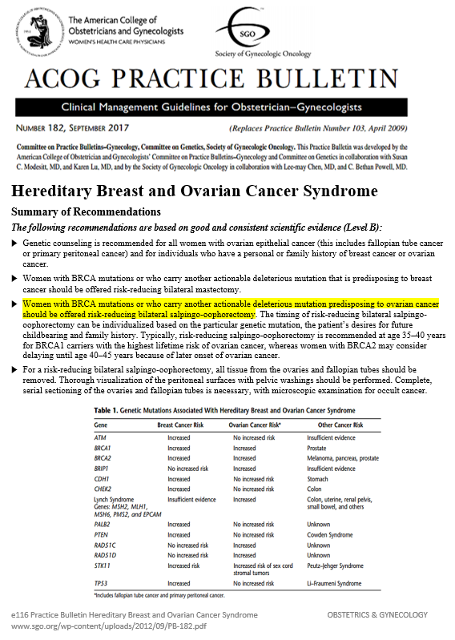
Exhibit D
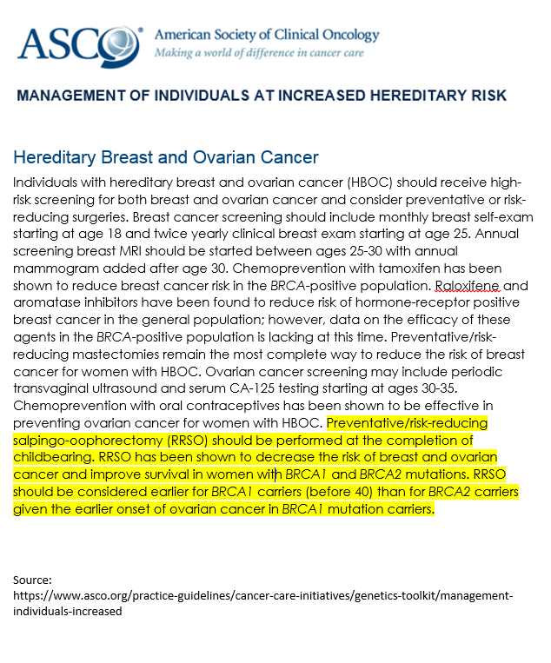

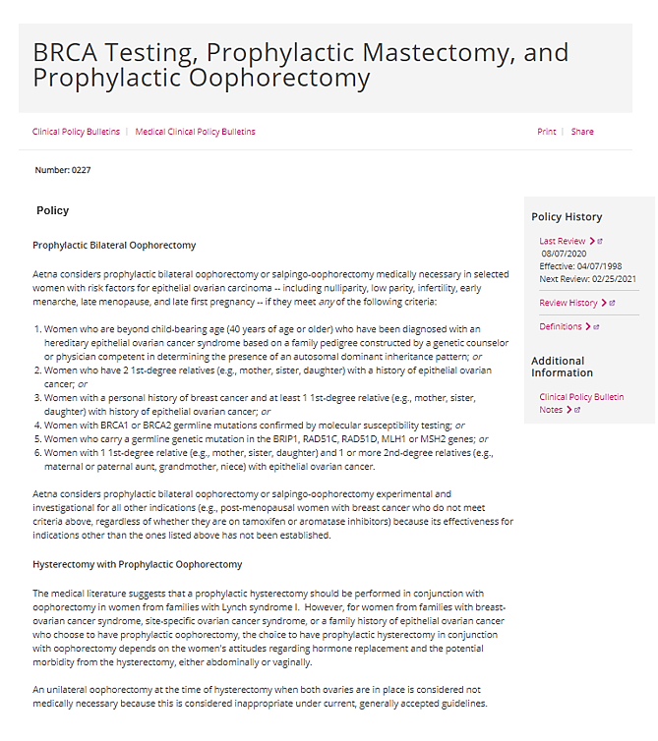
Exhibit E
Source: www.aetna.com/cpb/medical/data/200_299/0227.html

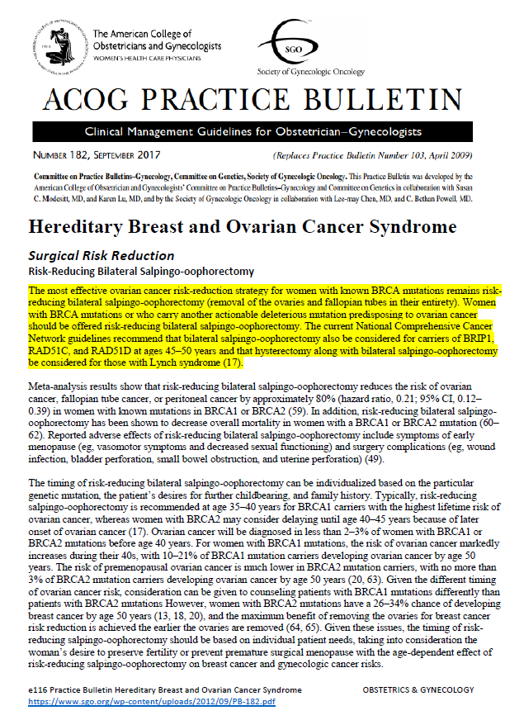

Exhibit F
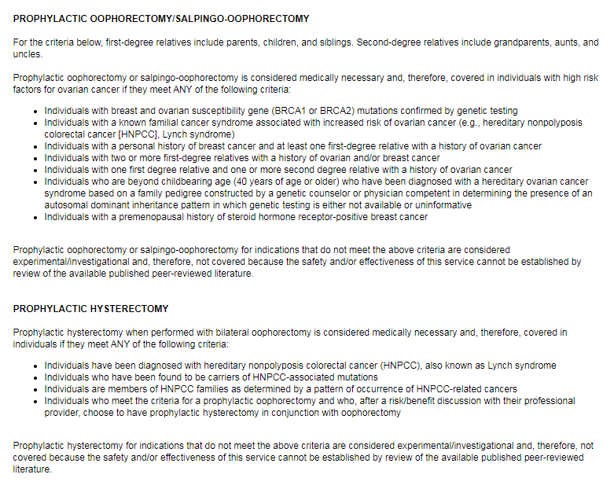
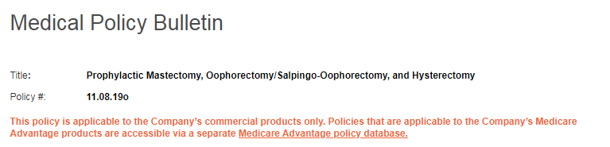
Source: http://medpolicy.ibx.com/policies/mpi.nsf/9f68d24e6270683785257a1b005a6de4/85256aa800623d7a85258596007ea05c!OpenDocument

BRCA-Related Cancer: Risk Assessment, Genetic Counseling, and Genetic Testing, August 2019 (www.uspreventiveservicestaskforce.org/Page/Document/UpdateSummaryFinal/brca-related-cancer-risk-assessment-genetic-counseling-and-genetic-testing)
Surgery to Reduce the Risk of Breast Cancer (www.cancer.gov/types/breast/risk-reducing-surgery-fact-sheet)
Ovarian Cancer Screening Tests: Safety Communication - FDA Recommends Against Use (https://wayback.archive-it.org/7993/20170404200850/https://www.fda.gov/Safety/MedWatch/ SafetyInformation/SafetyAlertsforHumanMedicalProducts/ucm519540.htm)

