HEALTH INSURER
123 Insurance Way
Anywhere, IL 012345
DATE
RE: Claim # XXXXXXXXXXX
Insured: NAME (ID# XXXXXXXXXXX)
Claimant: NAME (DOB Mo-Day-Year)

To Whom It May Concern:
I am writing to appeal [Health Plan Name]’s decision to deny coverage of genetic [counseling and/or testing] for a BRCA genetic mutation, which took place on [date] at [facility or physician’s office]. Under the Patient Protection and Affordable Care Act (ACA), any preventive health service recommended by the U.S. Preventive Services Task Force (USPSTF) with an A or B rating must be covered by a health plan. The USPSTF BRCA-Related Cancer: Risk Assessment, Genetic Counseling, and Genetic Testing guidelines give a “Grade: B” to screening women who may be at high risk of breast, ovarian, tubal, or peritoneal cancer. “Women with positive screening results should receive genetic counseling and, if indicated after counseling, BRCA testing.” [Exhibit A]
The U.S. Department of Health and Human Services and HealthCare.gov confirm this. “All Marketplace health plans and many other plans must cover the following list of preventive services for women without charging a copayment or coinsurance. This is true even if you haven’t met your yearly deductible.” My physician recommended genetic testing because my [personal and/or family] history is consistent with that of a hereditary cancer syndrome which places me at significantly increased risk of breast and ovarian cancer.
There is broad consensus about the medical benefits of genetic counseling and testing to identify people at high risk of breast, ovarian and other cancers. The National Comprehensive Cancer Network (NCCN) is a professional organization that develops standard-of-care consensus guidelines in cancer. Its practice guidelines for “Genetic/Familial High-Risk Assessment: Breast, Ovarian, and Pancreatic” reiterate the need to identify individuals affected by hereditary cancer syndromes via genetic testing and outline the recommended screening and preventive services for high-risk individuals. Professional organizations including the American Congress of Obstetricians and Gynecologists (ACOG) and Society of Gynecologic Oncology and the American Society of Clinical Oncology (ASCO) also recommend the screening and identification of women at increased risk of cancer.
Given this evidence, my health care team and I respectfully request that you reverse the denial of this claim. The law and ACA make it clear that genetic [counseling and/or testing] are important preventive services which should be covered at no cost for women such as myself.
Thank you for your consideration. Your prompt attention to this appeal is greatly appreciated.
Sincerely,
[Signature]
Exhibit A

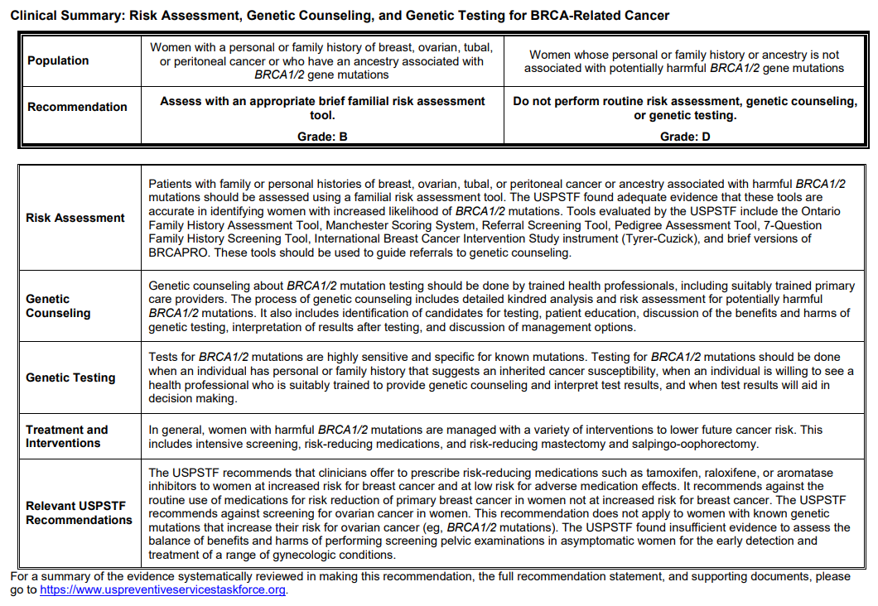
Source: USPSTF BRCA-Related Cancer: Risk Assessment, Genetic Counseling, ad Genetic Testing - August 20, 2019
https://www.uspreventiveservicestaskforce.org/uspstf/recommendation/brca-related-cancer-risk-assessment-genetic-counseling-and-genetic-testing

Preventive care benefits for women (www.healthcare.gov/preventive-care-women/)
NCCN Clinical Practice Guidelines in Oncology: Genetic/Familial High-Risk Assessment: Breast, Ovarian, and Pancreatic, Version 1.2023 — September 7, 2022 (www.nccn.org/professionals/physician_gls/pdf/genetics_bop.pdf)
Hereditary Cancer Syndromes and Risk Assessment (www.acog.org/Clinical-Guidance-and-Publications/Committee-Opinions/Committee-on-Genetics/Hereditary-Cancer-Syndromes-and-Risk-Assessment) and ACOG Practice Bulletin: Hereditary Breast and Ovarian Cancer Syndrome (www.sgo.org/wp-content/uploads/2012/09/PB-182.pdf)
American Society of Clinical Oncology Policy Statement Update: Genetic and Genomic Testing for Cancer Susceptibility (http://ascopubs.org/doi/10.1200/JCO.2015.63.0996)

